LAB-1

**AIM: Setting up JENKINS environment using MAVEN AND GITHUB…**

Step: 1

Creating Github Repo.

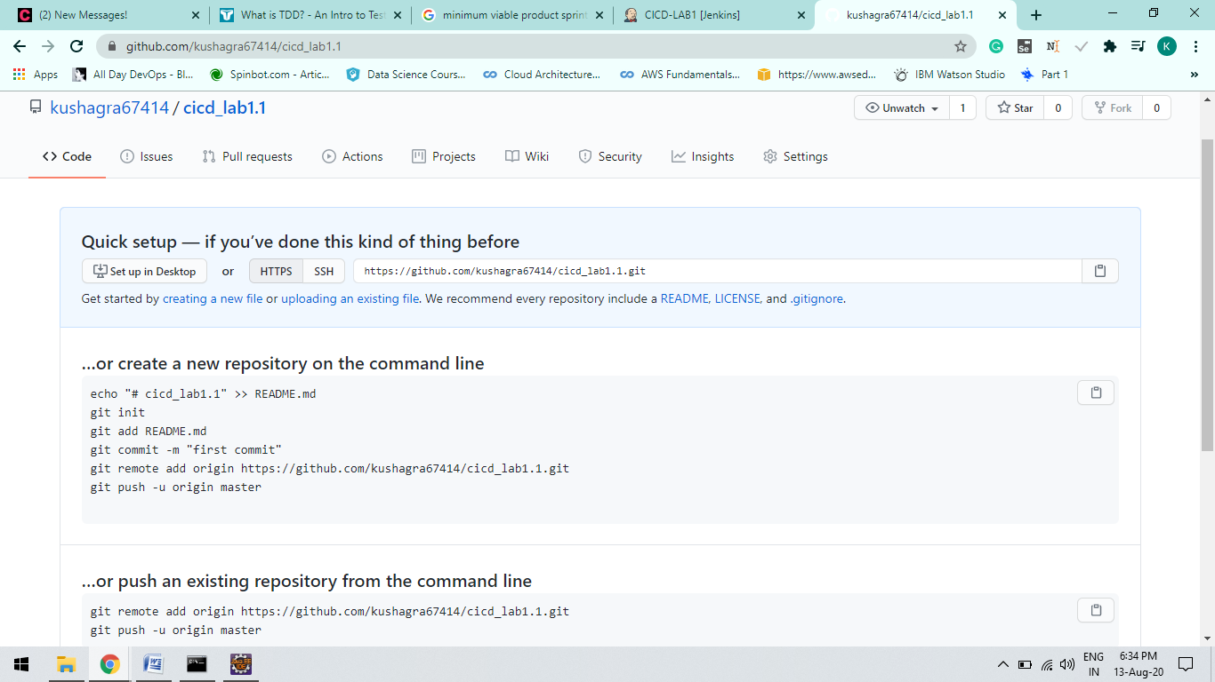

Step: 2

**Using Eclipse IDE Add Maven project to Github Repo you first created**

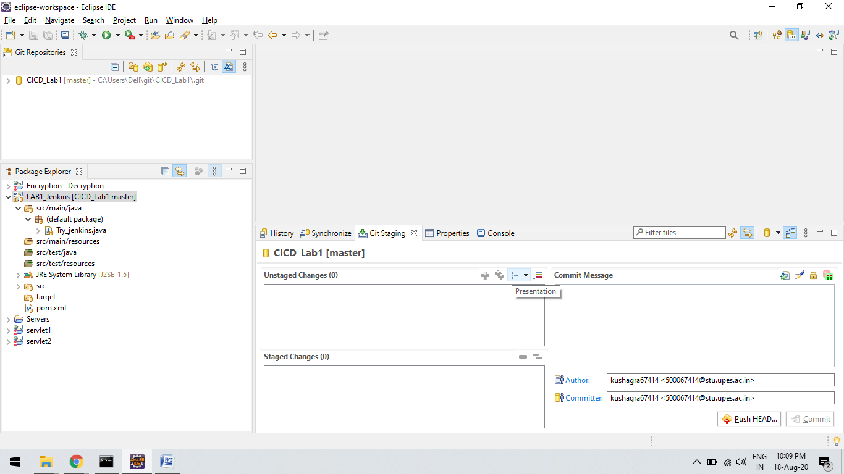

Step 3 :

Create a JOB on JENKINS AS “cicd_lab1” and Configure it..

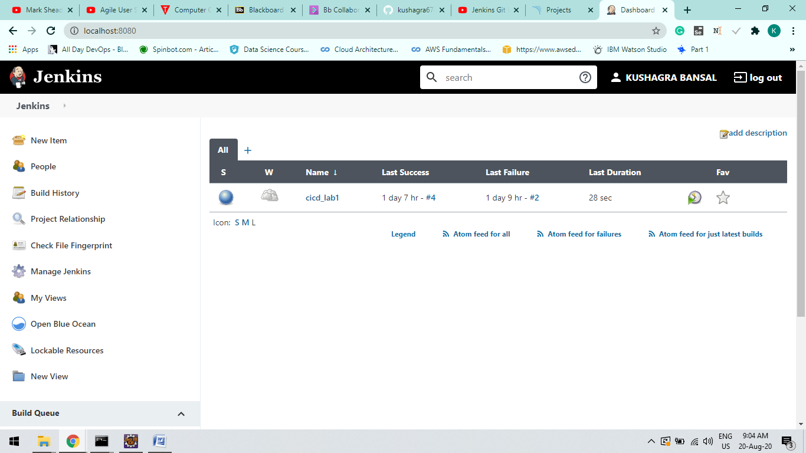

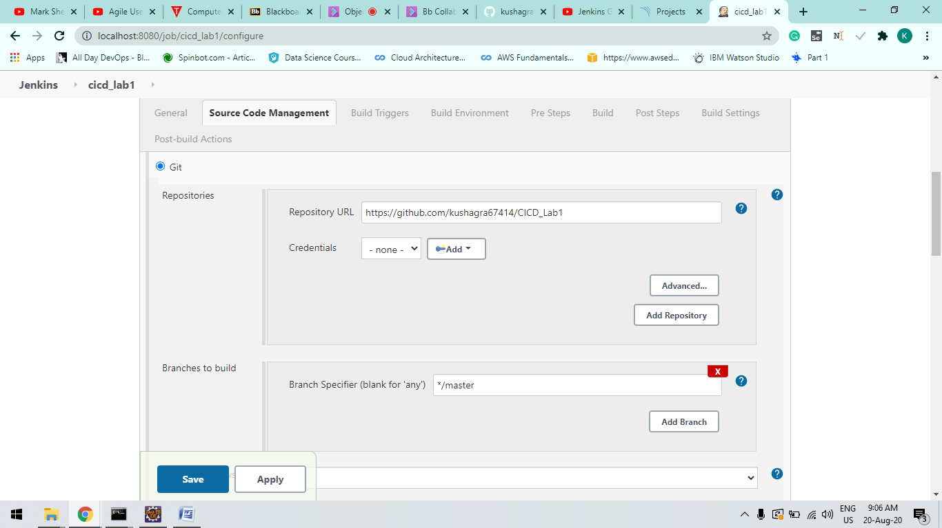

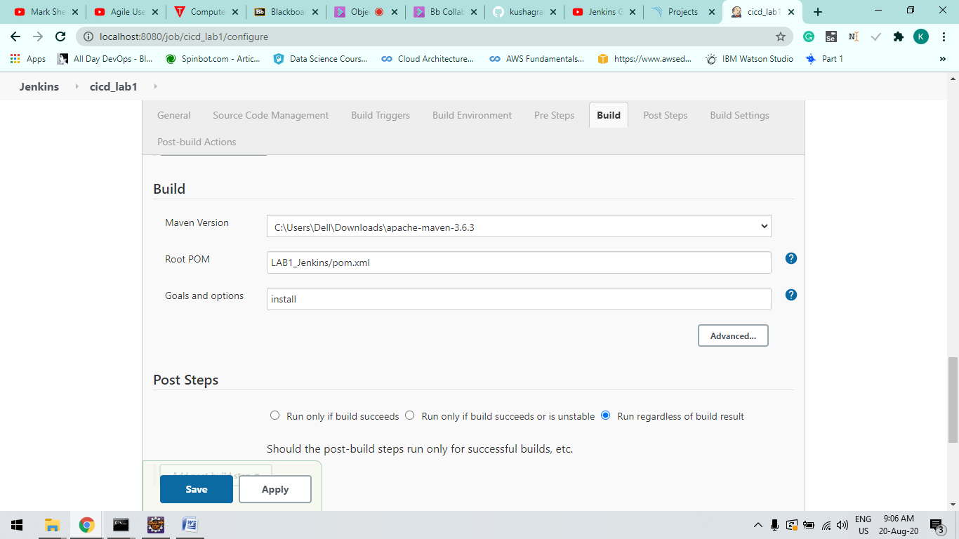

*Step-4 :*

**Now Click on Build now Option at Left Side of you window and verify the Build Success**

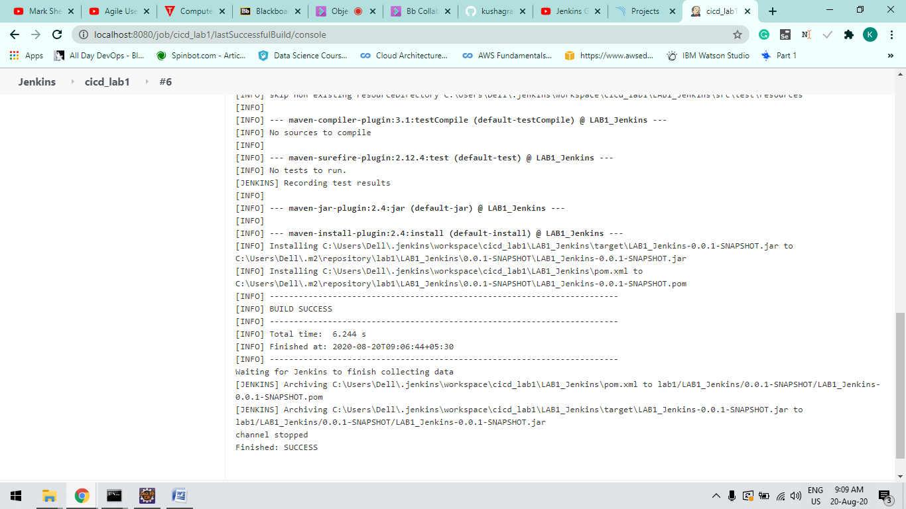

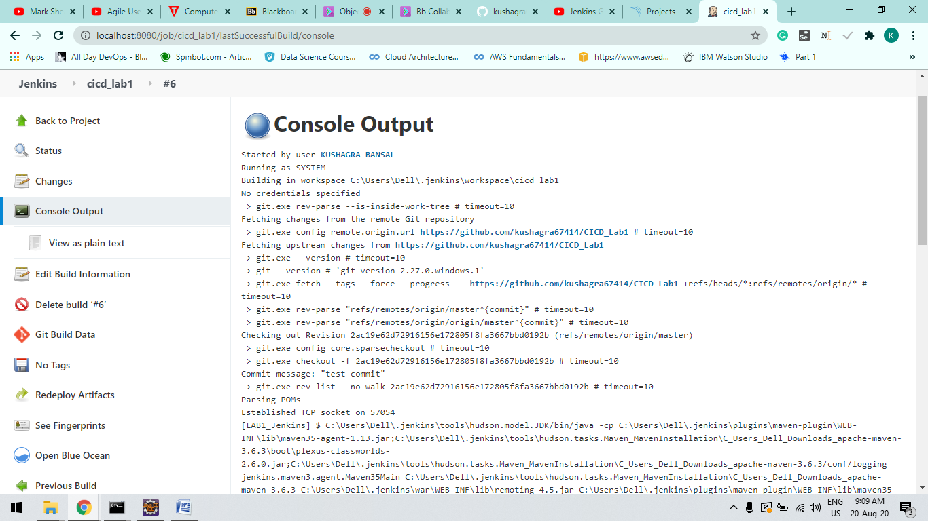

***LAB -2***

AIM : Using Static Code analysis Tool “SONARQUBE”

Step-1: Setup Maven Project using Eclipse IDE and open Sonarqube at localhost.

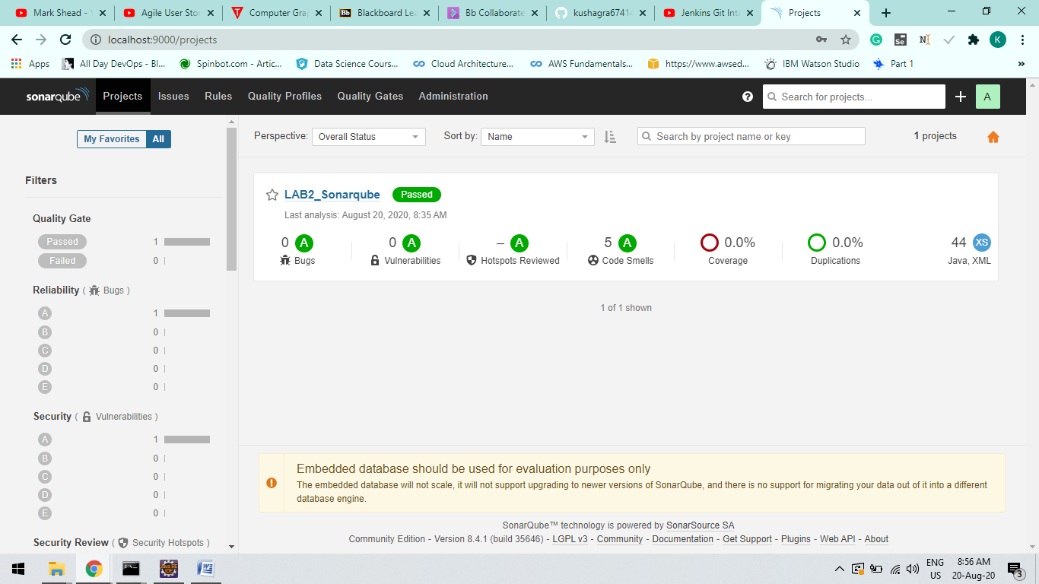

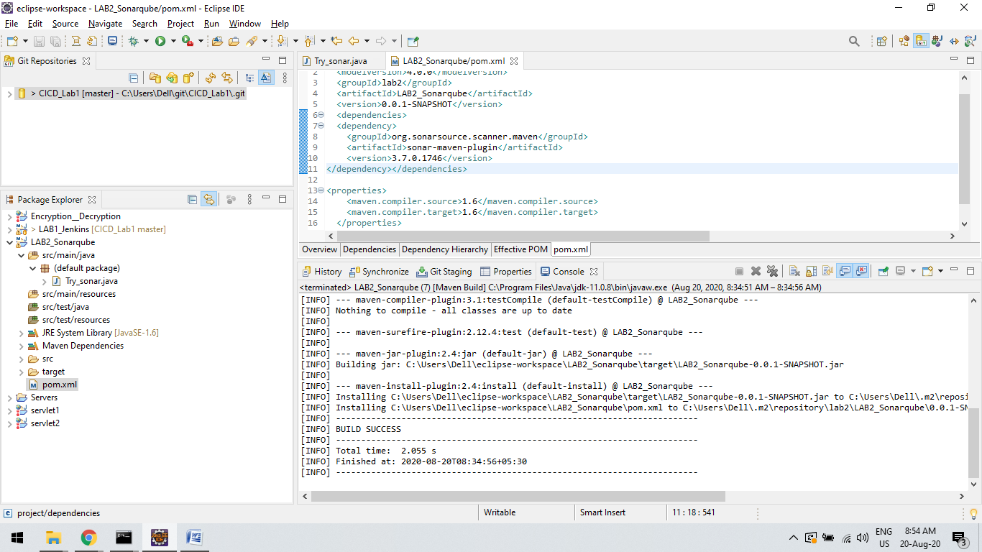

Step-2:

Open Project Path and use Command : “mvn clean install sonar:sonar

-Dsonar.host.url=http://localhost:9000 -Dsonar.analysis.mode=publish”

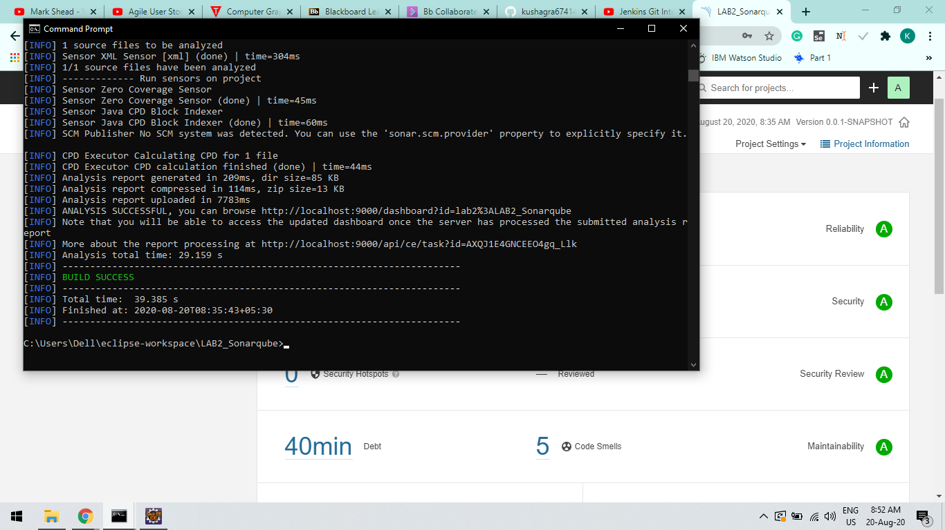

Step-3:

Now you can check Bugs , Vulnerabilities, Code Coverage, Code Smells, Duplications etc….

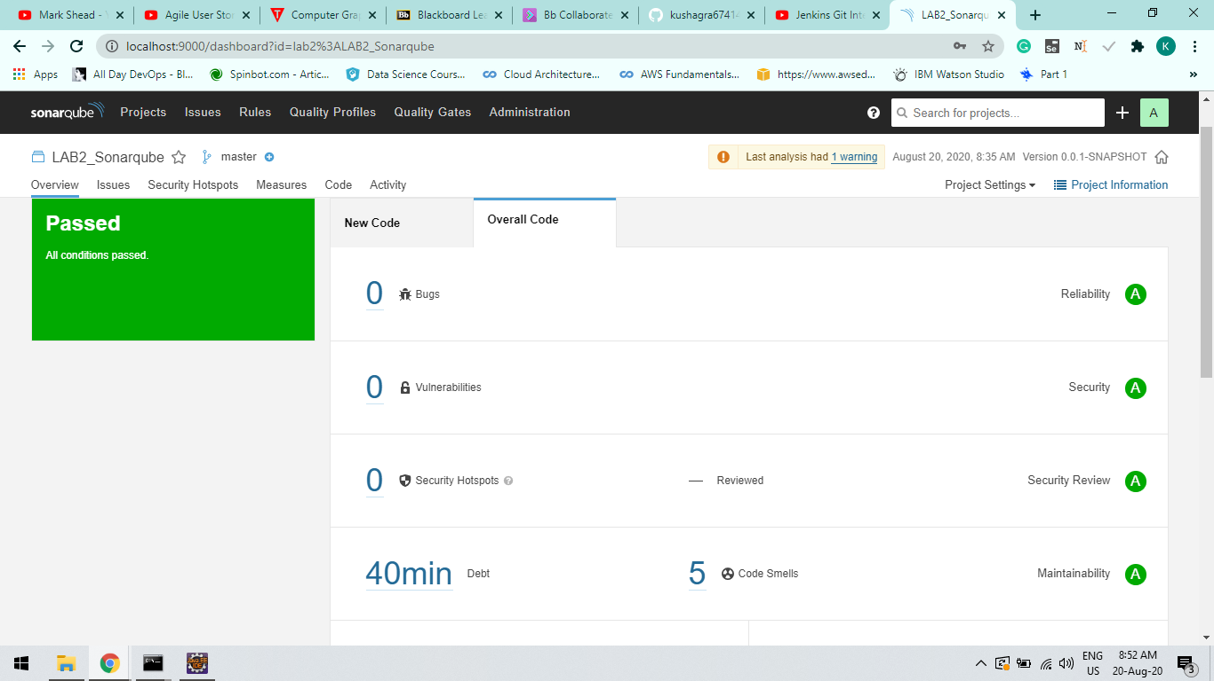

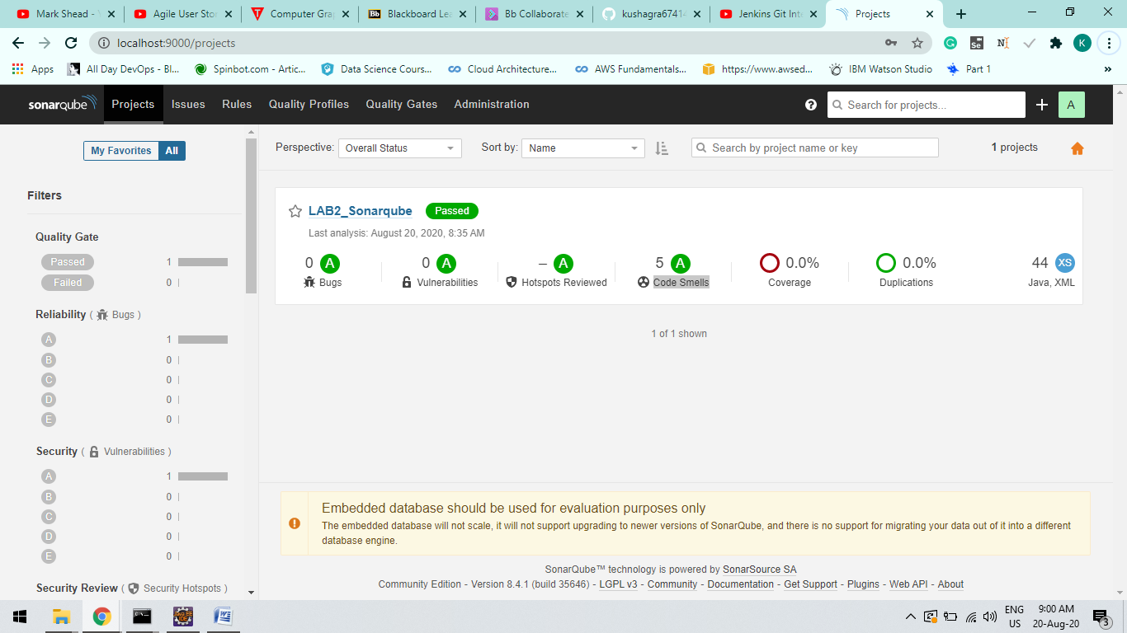

***LAB - 2.1***

AIM : Intregrating Jenkins , Maven, Sonarqube, Github and Eclipse IDE..

Step-1

Intregate Github and Eclipse As Previously done in above Experiment.

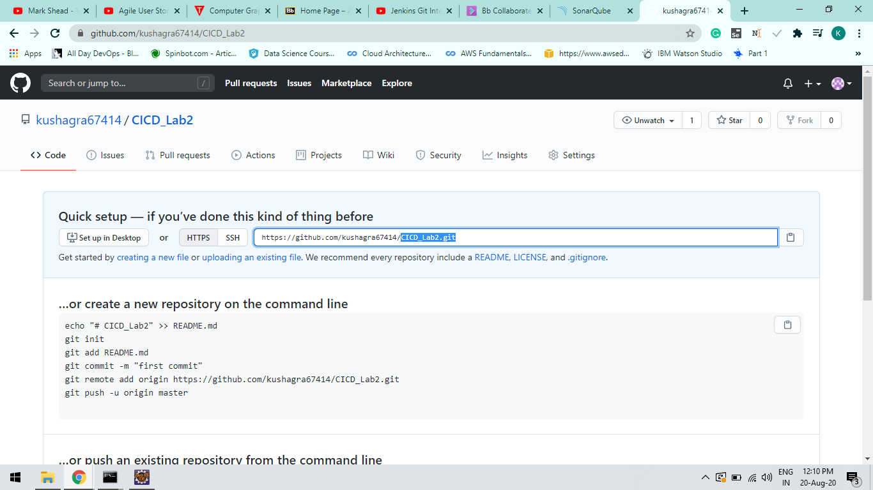

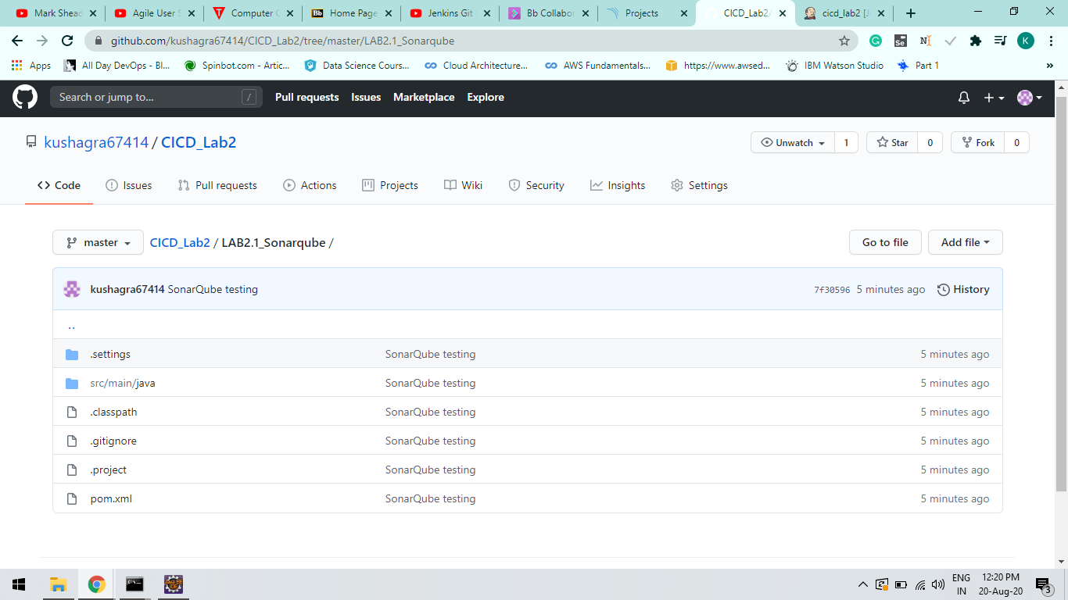

Step-2

Instead of using Maven Cli configure Jenkins and give the path of the Maven Goal and Plugin.

Command : “mvn clean install sonar:sonar

-Dsonar.host.url=http://localhost:9000 -Dsonar.analysis.mode=publish”

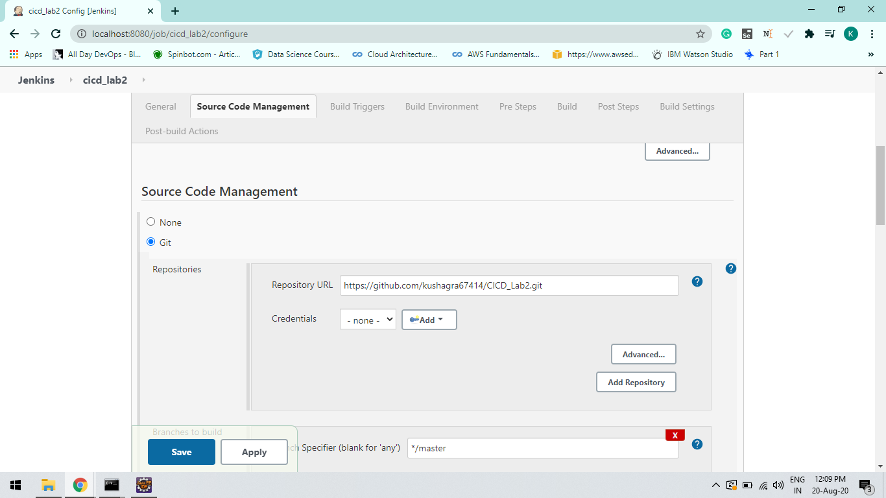

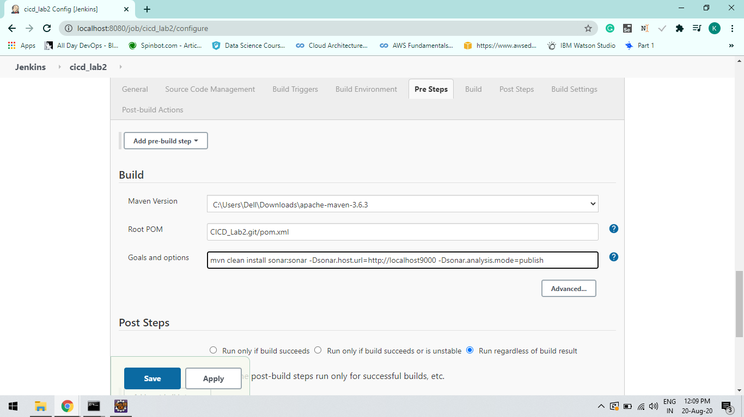

Step-3:

Build the Project and IT will automate the project at Sonarqube.

Check your Build on Console Output.

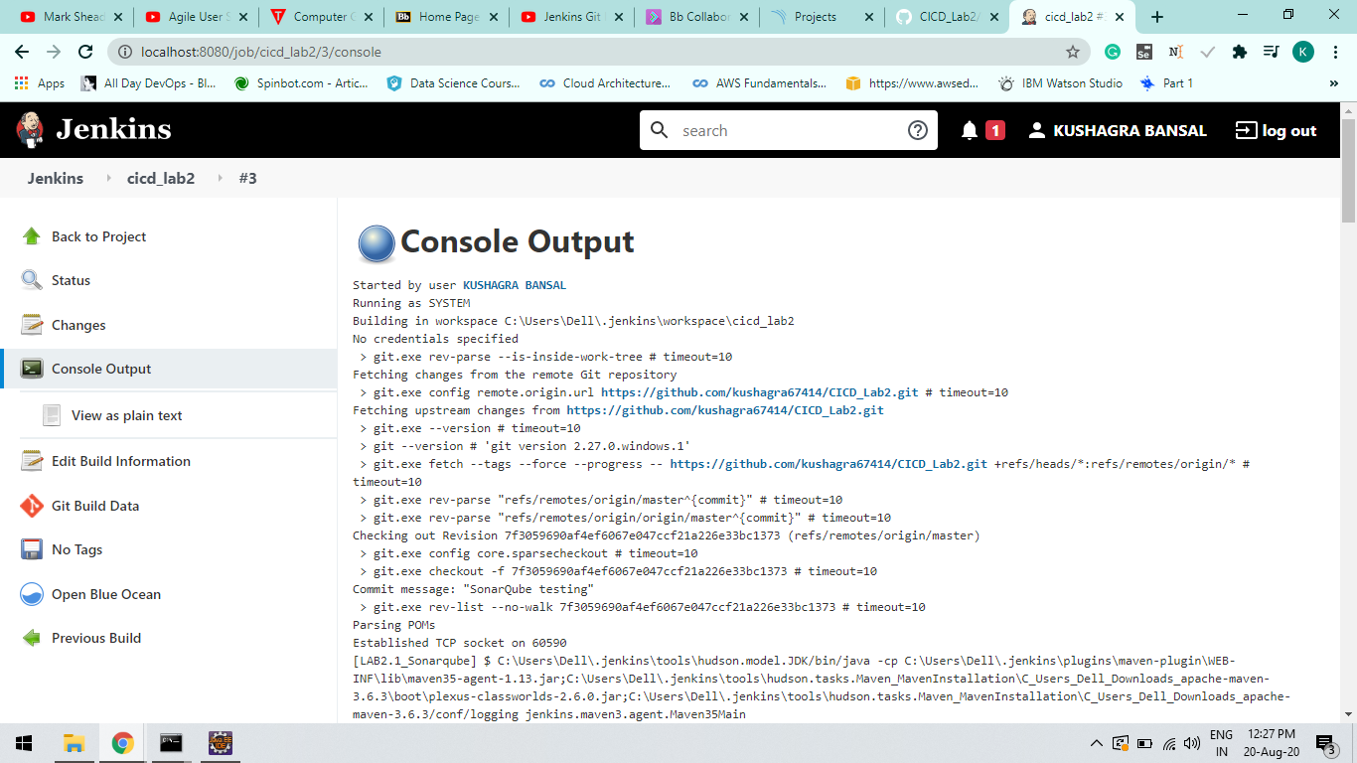

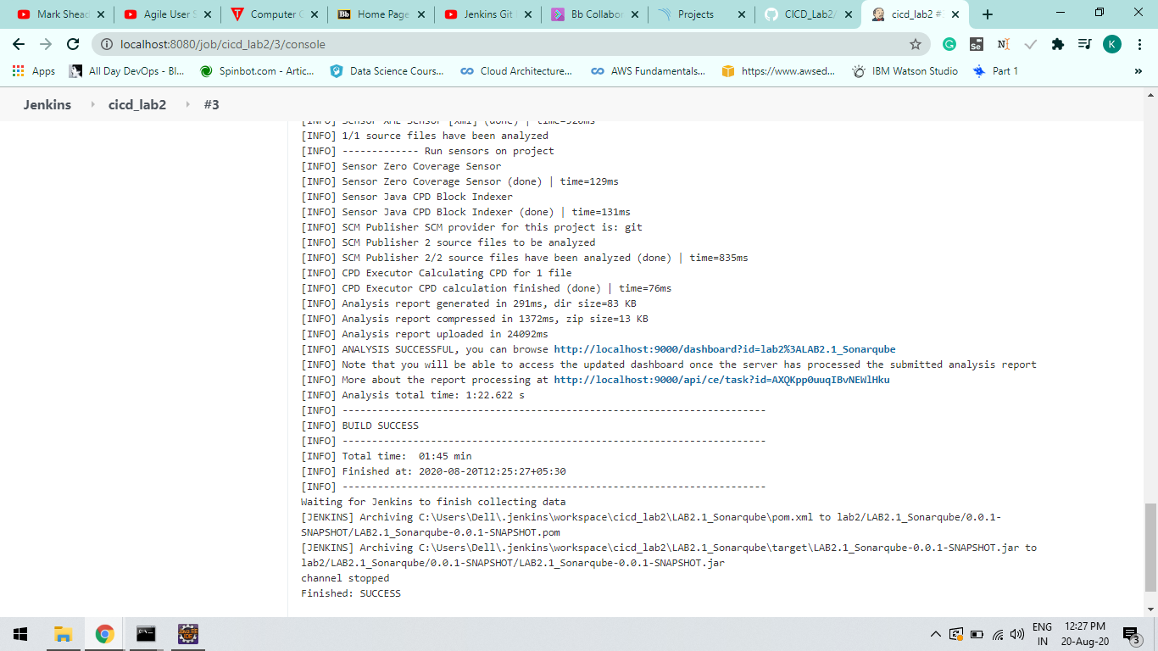

Step-4

Refresh and Check Sonarqube.

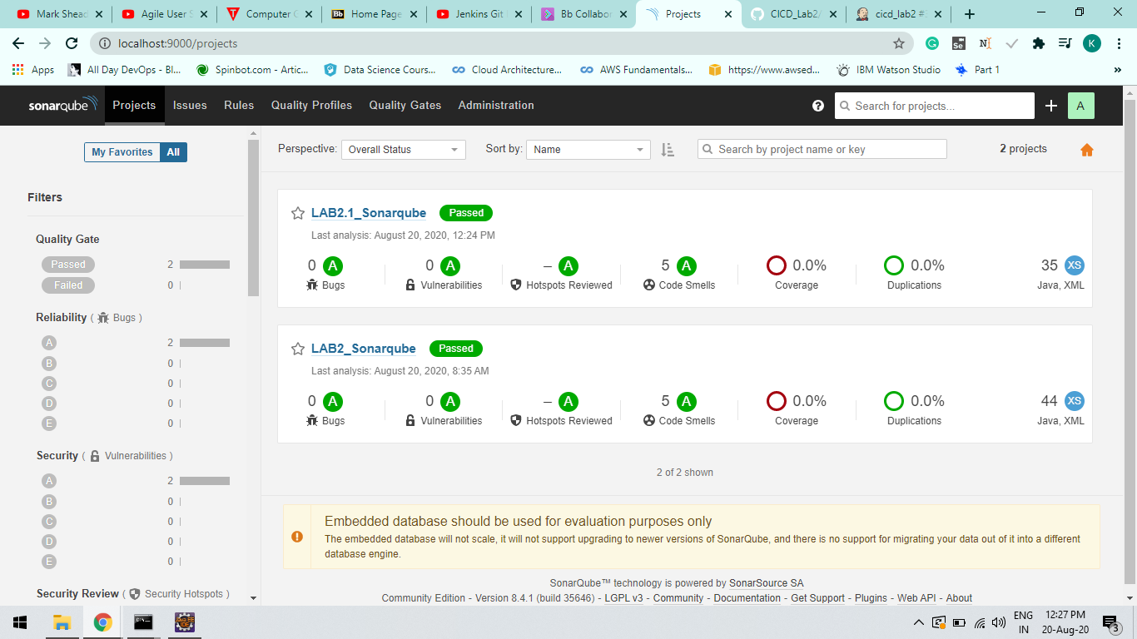

***LAB – 4***

Aim : Creating a pipeline

Step-1:

Create jenkinsfile script file

Jenkinsfile must not be inside any subfolder of github.

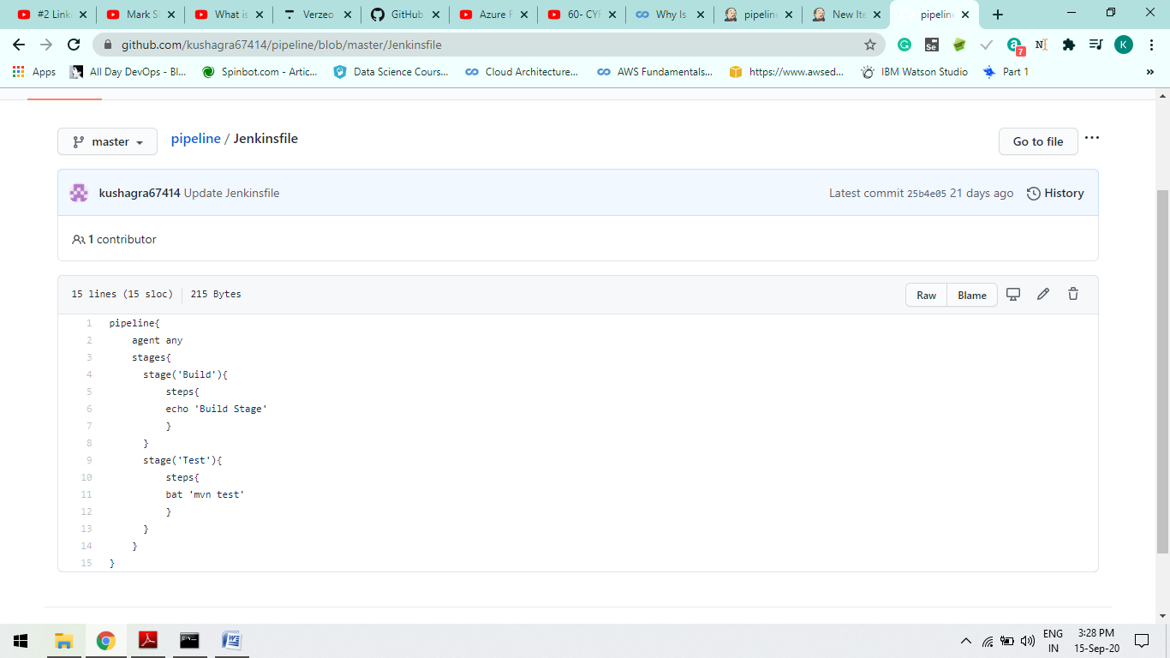

Step-2

Create a Project at Jenkins localhost and Configure it

Also while giving a github repo path in configurations must use “git” extension

If Your repo name is Pipeline then “.git ” is necessary ext at that time.

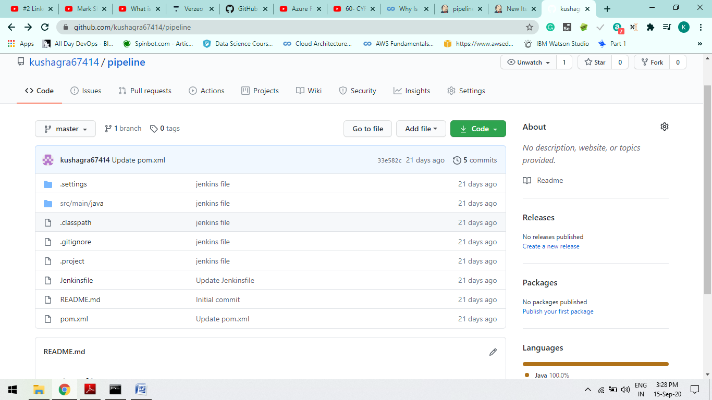

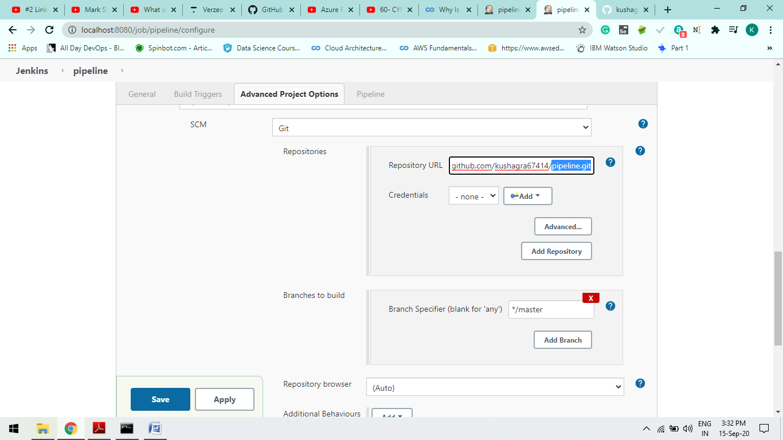

I

Step-3

Build Now and see the maven goals output define in jenkinsfile script.

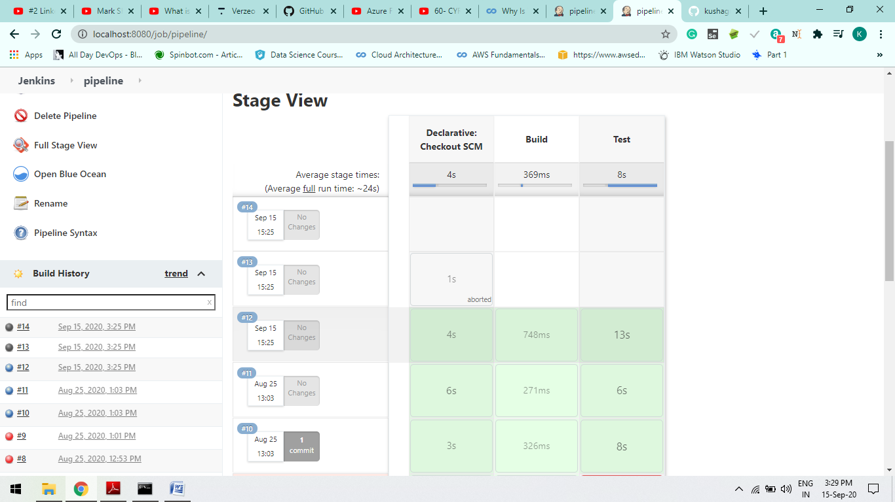

Step-4

Outputs of log Success =>

1. Build log:

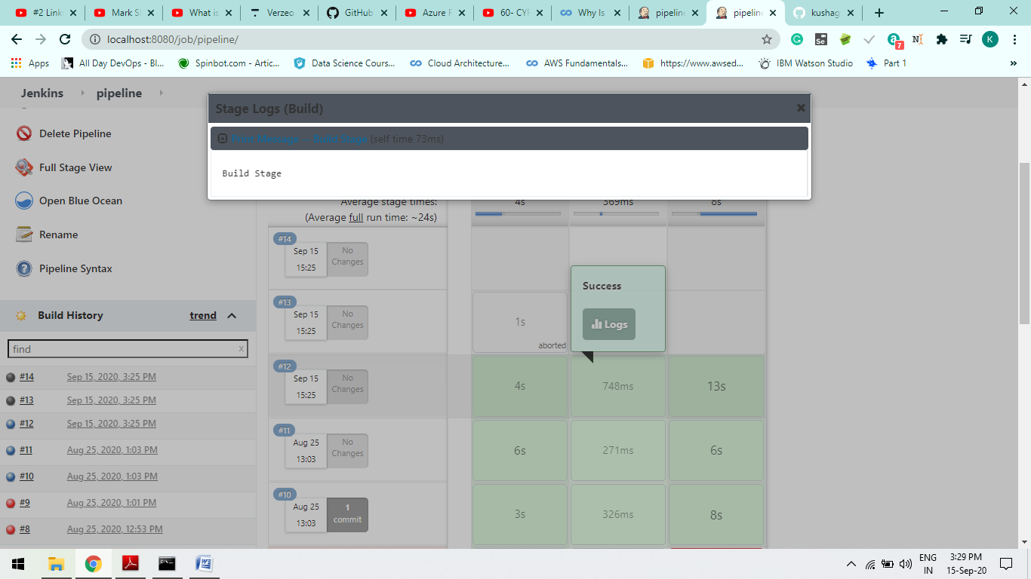

1. Test log:

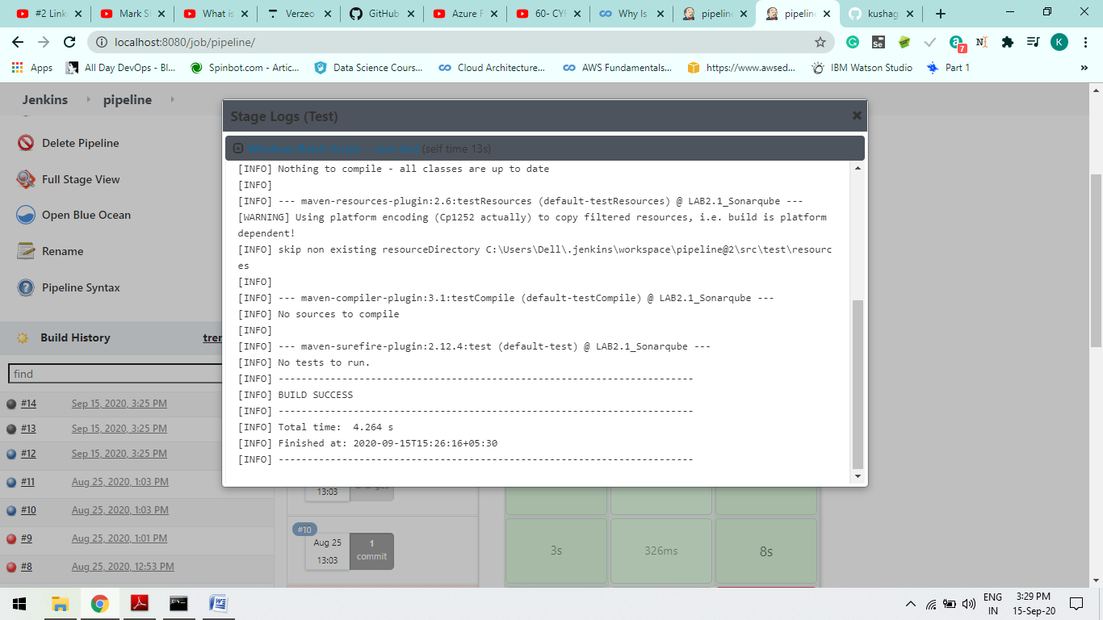

1. **Declarative: Checkout SCM**

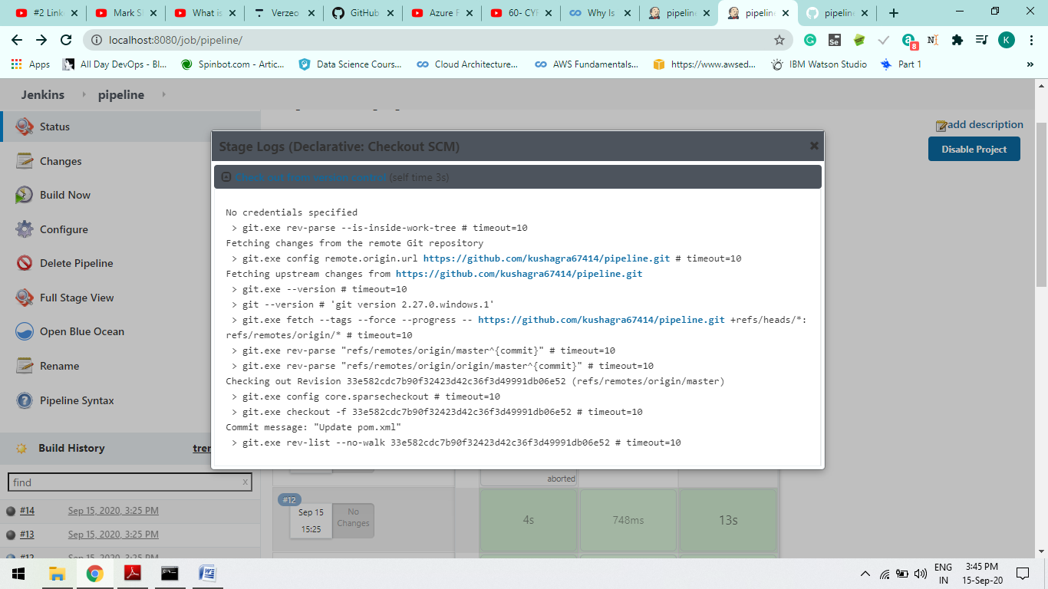

Lab-5

***AWS AMI with Terraform***

By: Kushagra Bansal

DevOps Enthusiast

STEP-1: Create IAM user and provide ADMINISTRATOR ACCESS [imp ]

A

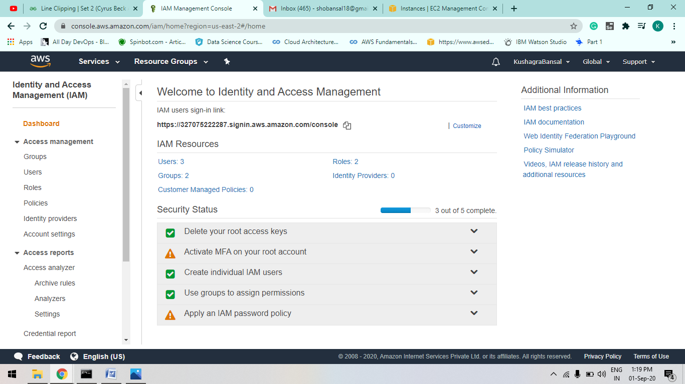

B

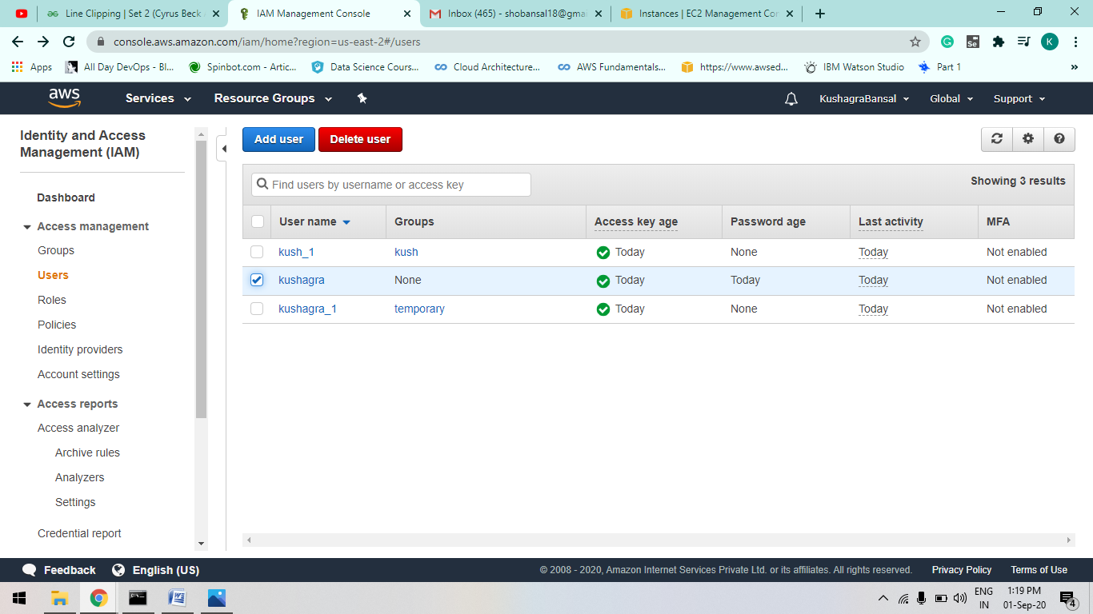

C

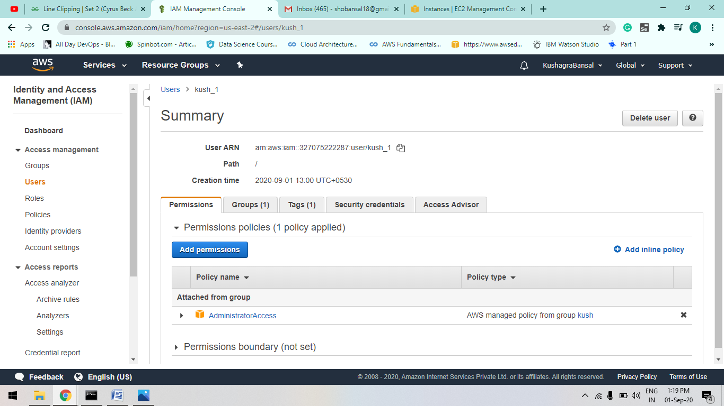

D

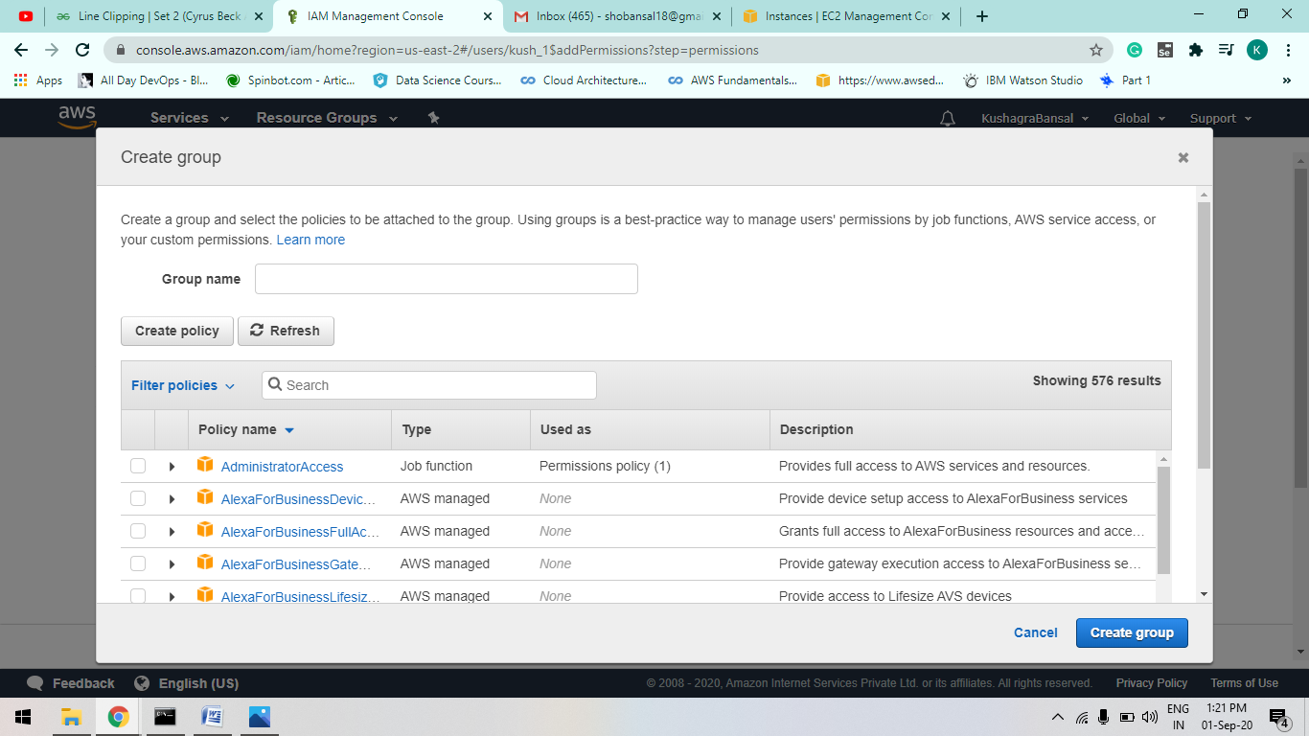

STEP-2: create xyz.tf file and configure it.. such as add security key and access key.

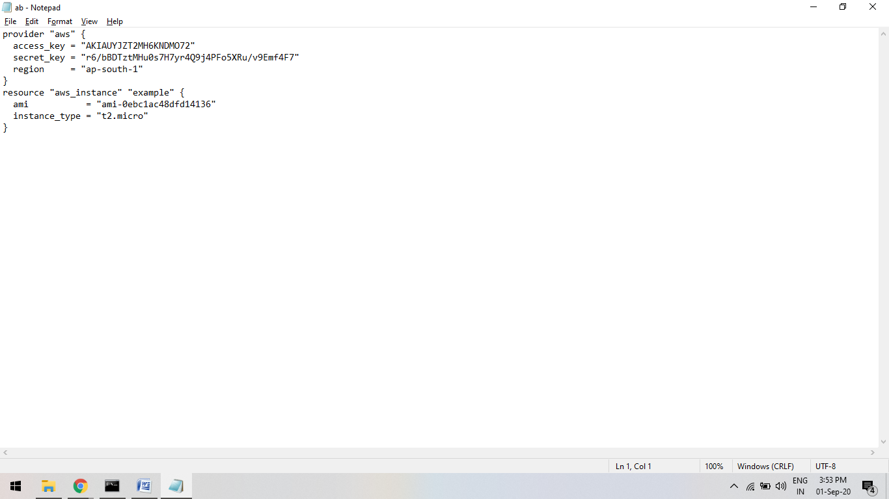

STEP-3:

Now run Command : “terraform plan”

Basically it create an aws_instance of which u give ami id while configuring your ab.tf file

[remember it must be in terraform folder ]

The terraform plan command is used to create an execution plan. Terraform performs a refresh, unless explicitly disabled, and then determines what actions are necessary to achieve the desired state specified in the configuration files.

A

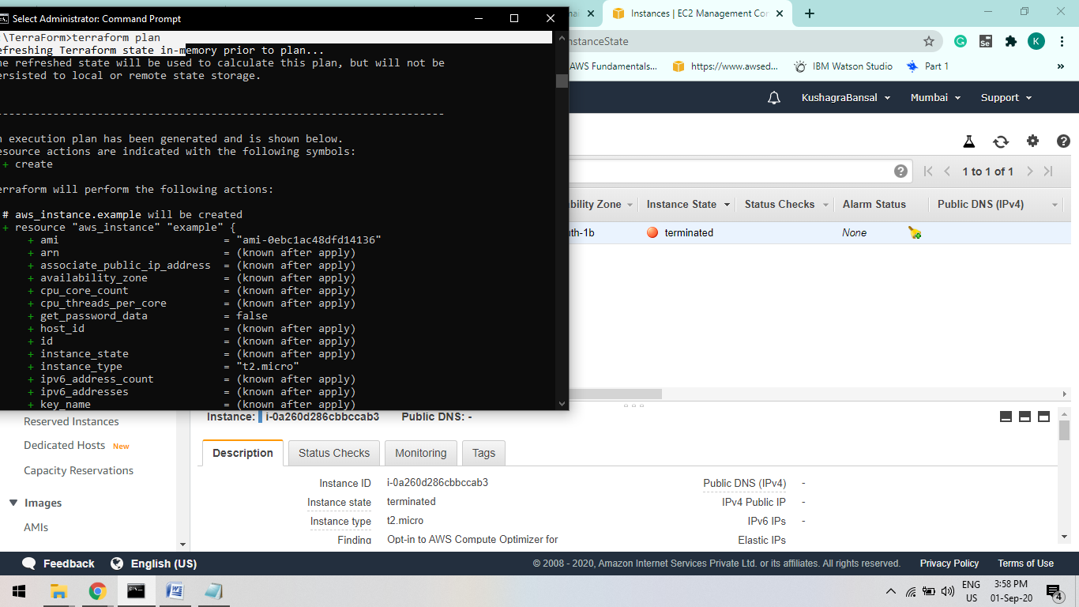

B

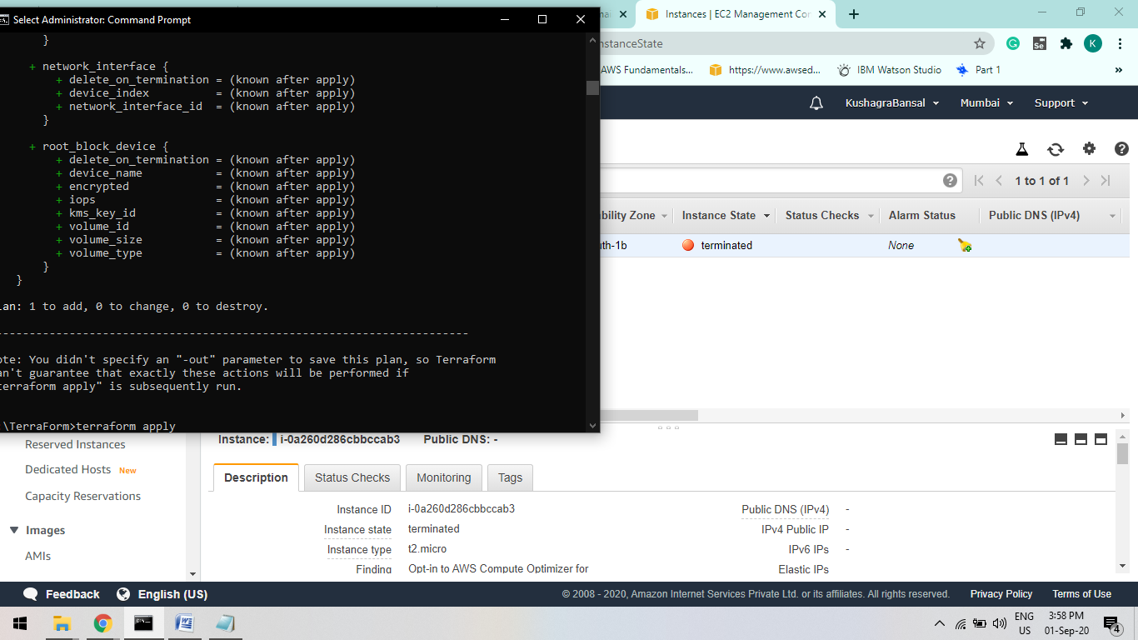

STEP-4:

Now run “terraform apply ”

he **terraform apply** command is used to **apply** the changes required to reach the desired state of the configuration, or the pre-determined set of actions generated by a **terraform plan** execution **plan**.

A

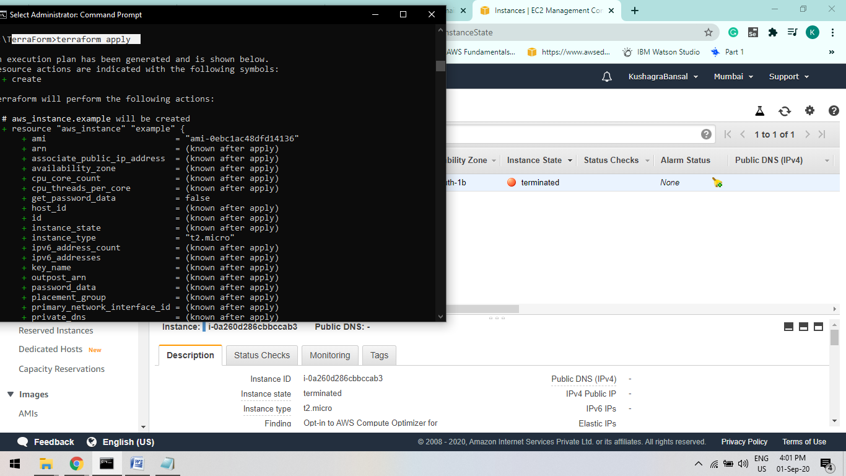

B

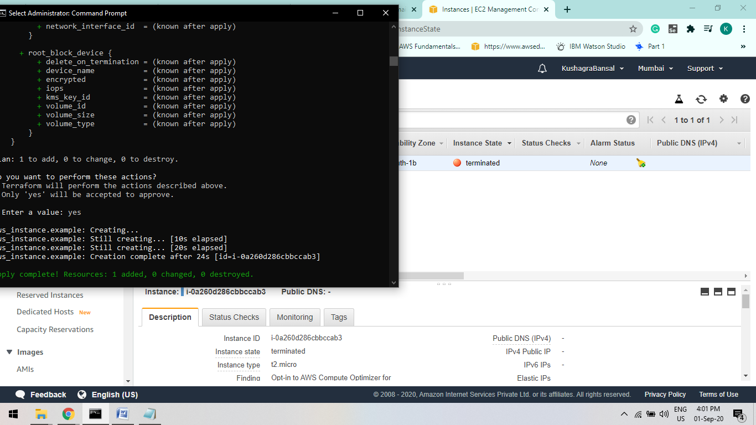

STEP-5:

Infrastructure managed by Terraform will be destroyed. This will ask for confirmation before destroying.

Run: “terraform destroy ”

a.

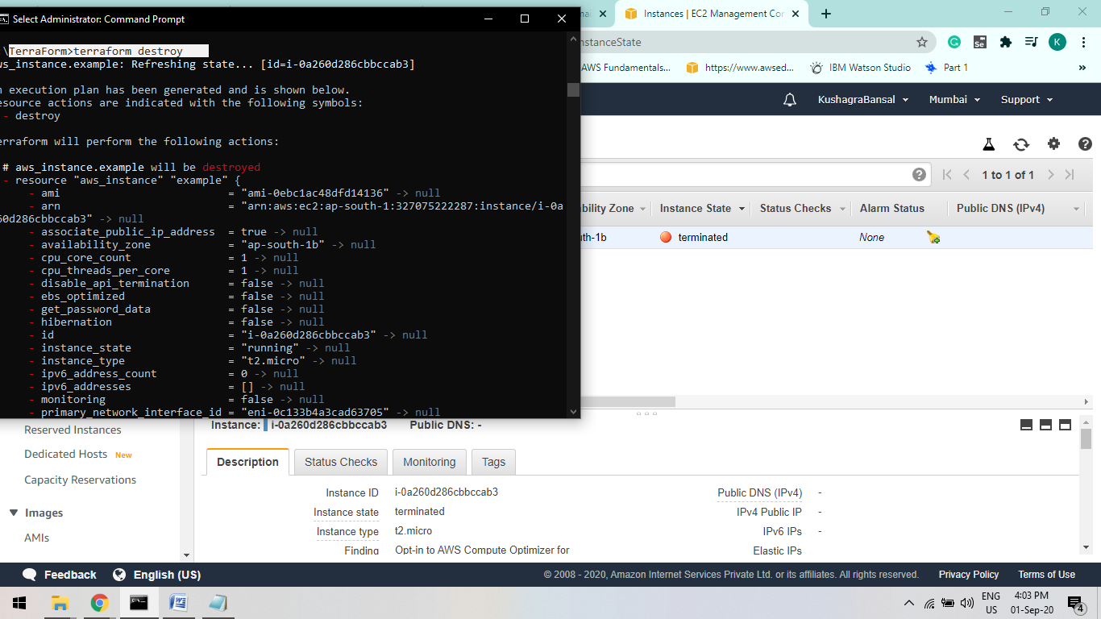

b.



STEP_6:

Refresh your aws webpage

It will take a few minute.

You will First it show “SHUTTING DOWN” After Few Minutes “TERMINATED”.

A.

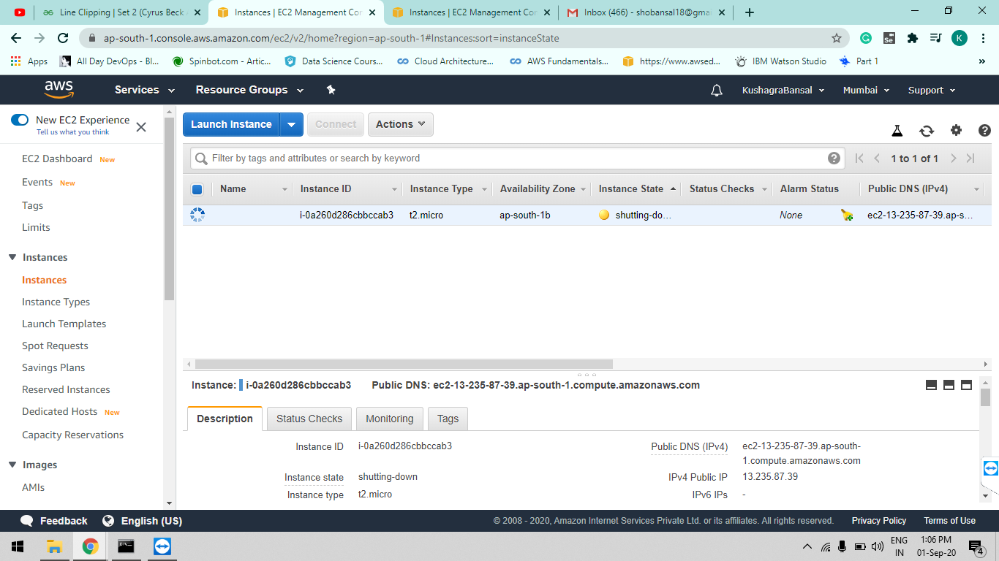

B.

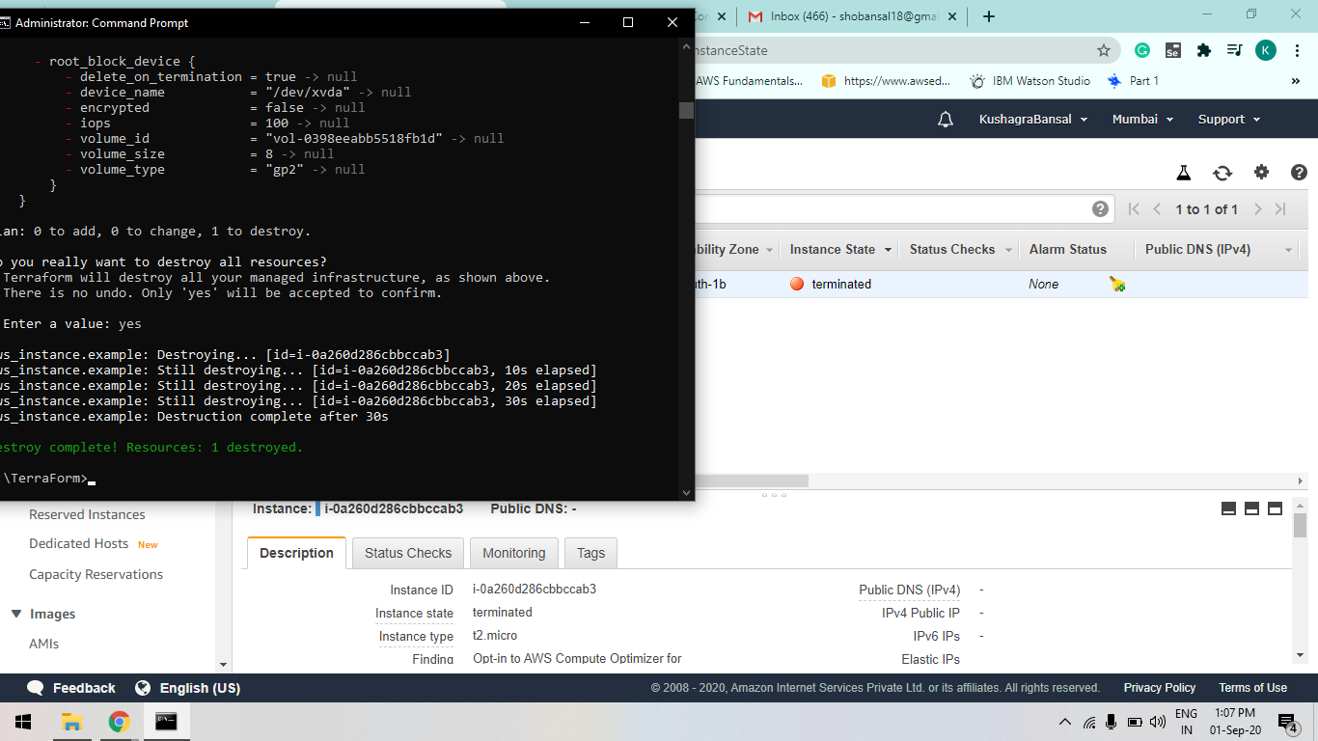

**CICD LAB-6 Experiment**

**Aim : Working of Slave in Jenkins :**

Note :

If Jenkins show invalid user name or not able to access.

Type : Jenkins.exe stop

It will stop all Jenkins service.

Then start your Jenkins using :

Java –jar Jenkins.war

**Step-1:**

Goto “manage Jenkins> Configure Global Security >”

Goto agent property option and select “random” option

**Step-2:**

Goto “manage Jenkins > Manage Nodes”

Create new node say “Slave_1”

Give description name (anything) say Slave_exp

Configurations we have to do :

1. Remote Root Directory : create a folder In local machine say “jenkins_slave_1” and give path of folder in it.

It will act as a workspace where our slave’s will be stored.

1. Usage option : Select “Use this nodeas much as possible”.
2. Launch method : Select “Launch agend by connecting it to the master”. This option will we occur if you have chosen “Random” option earlier in your configuration file.
3. Custom WorkDir path : path of your workspace folder. [ same as Remote Root Directory ]

Save the configurations

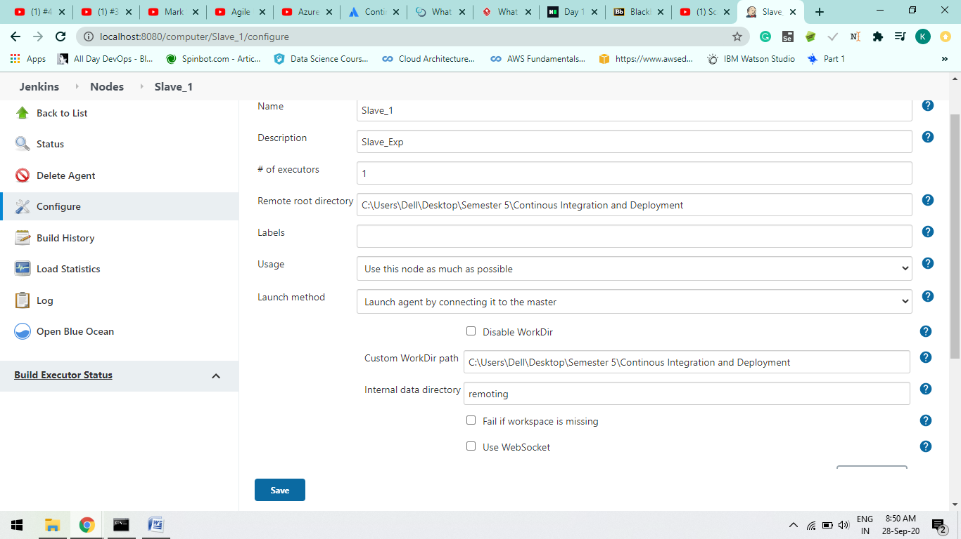

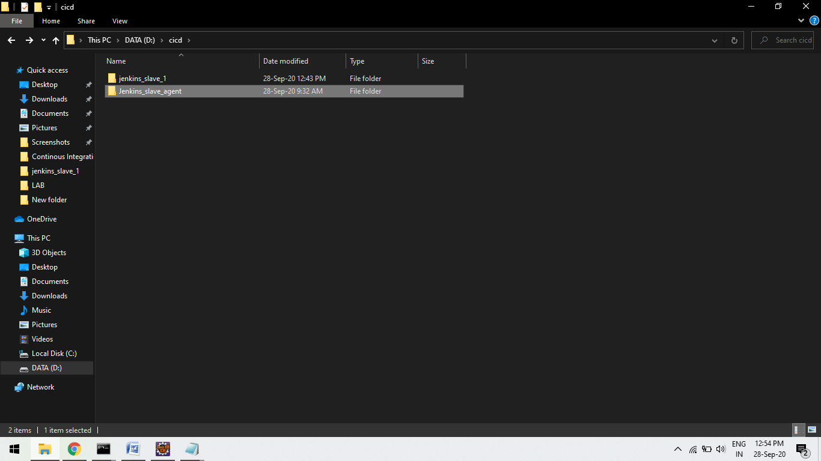

**Step-3:**

Now Slave is create but it is not connected to the master.

So click on the Slave_1

Click on the agent.jar , it will download the file as it helps to activate or launch the agent on command line.

Download it and create a folder at local machine and save it to that Folder

Folder name lets say : “Jenkins_slave_agent”

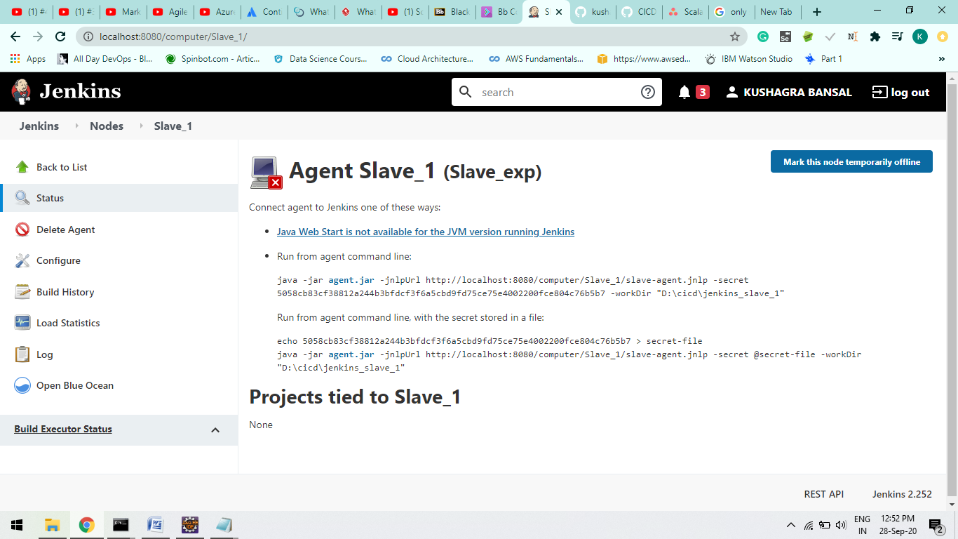



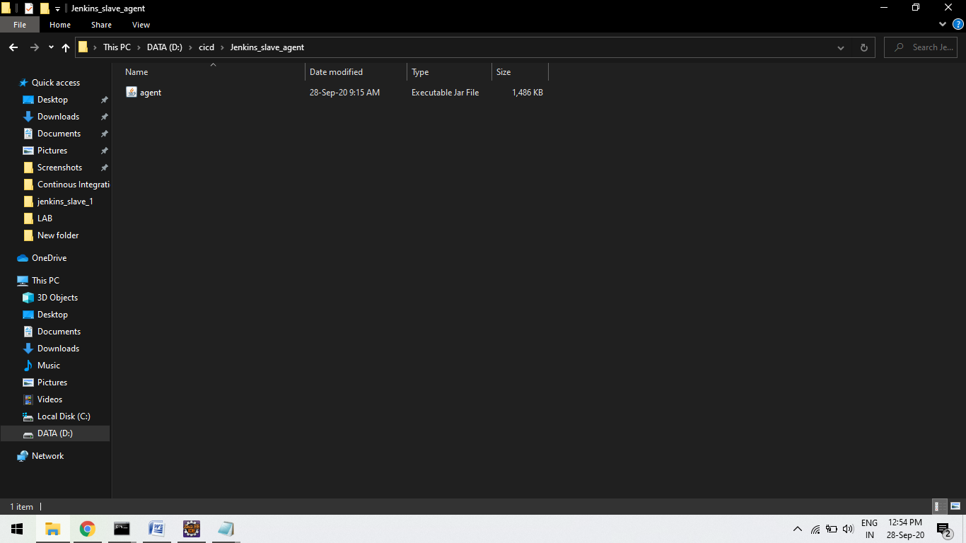

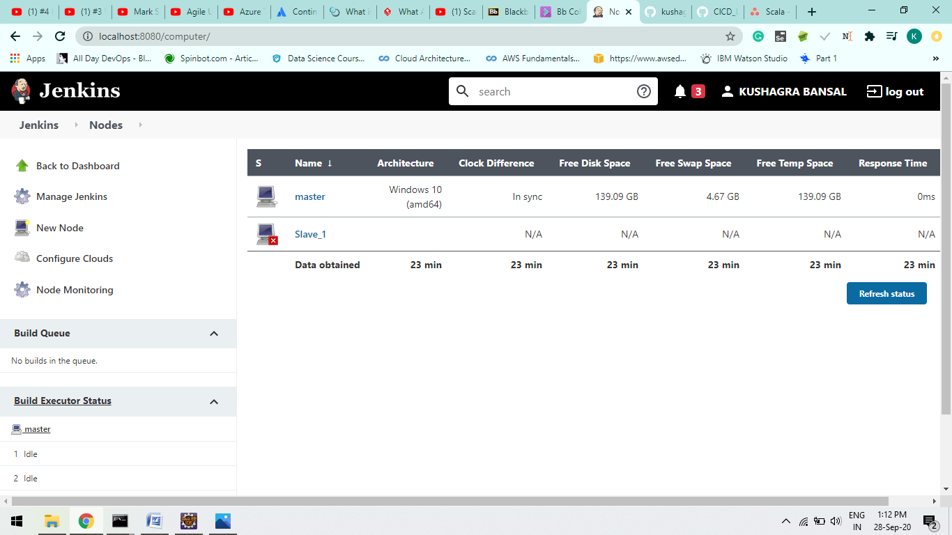

Sfrdv

**Step-4:**

java -jar D:\cicd\Jenkins_slave_agent\[agent.jar](http://localhost:8080/jnlpJars/agent.jar) -jnlpUrl http://localhost:8080/computer/Slave_1/slave-agent.jnlp -secret 5058cb83cf38812a244b3bfdcf3f6a5cbd9fd75ce75e4002200fce804c76b5b7 -workDir "D:\cicd\jenkins_slave03"

Type will connect node to its master node.

Refresh you will see slave is connected to its master node.

A



After the node is connect u will see RED CROSS LOGO is disappear.

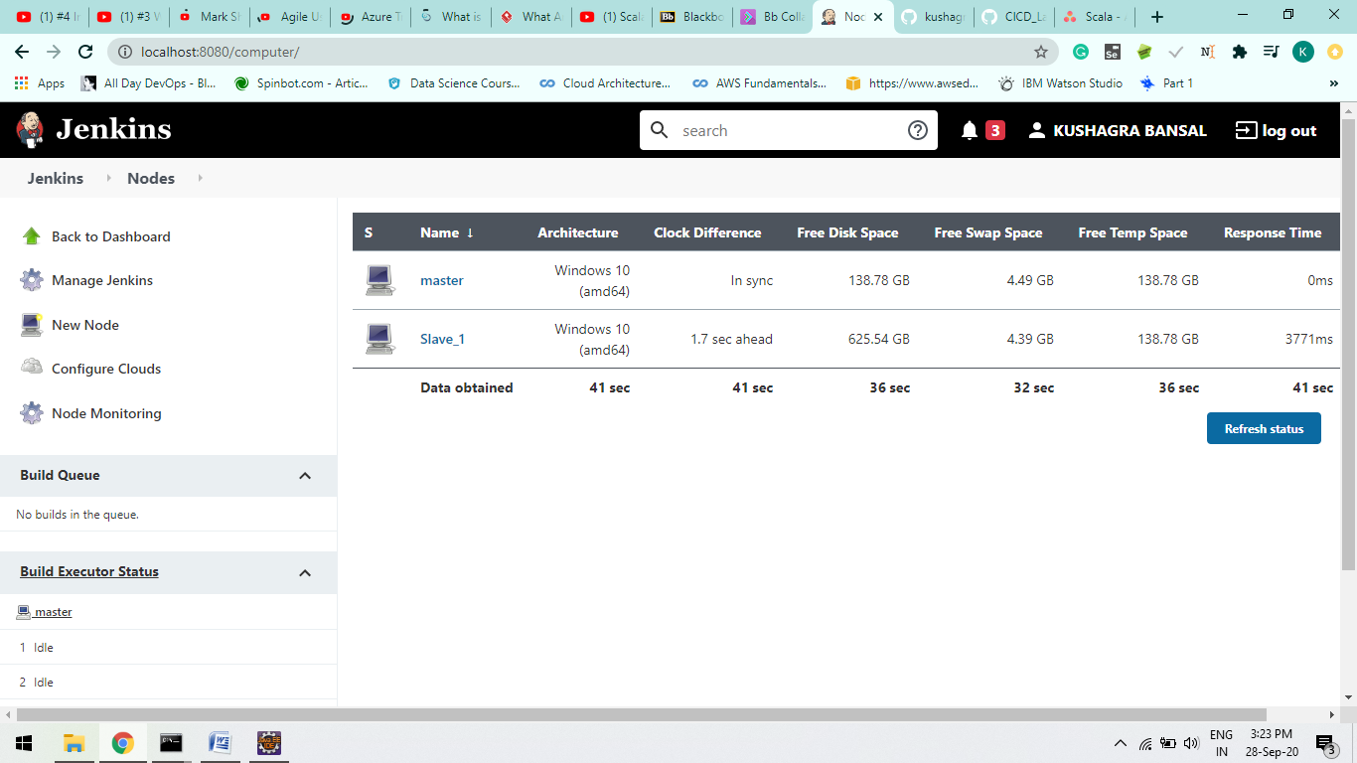

**Step-5:**

Create a Github repo and push a maven project.

Create a project in Jenkins and configure it by giving github repo path

As mentioned in Screenshots.

A

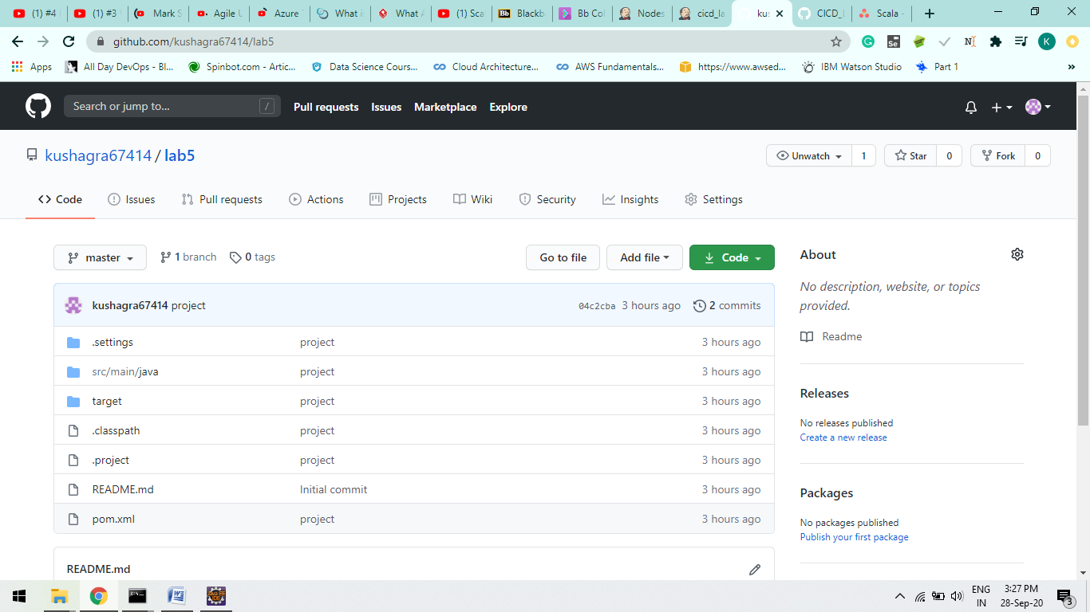

B

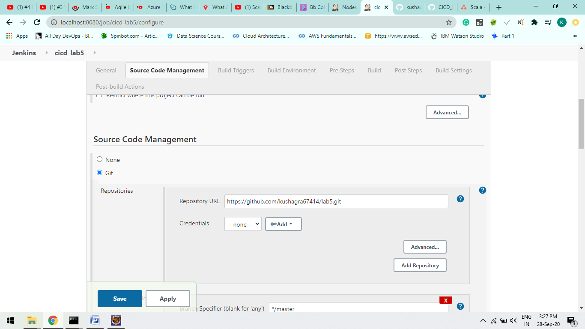

C

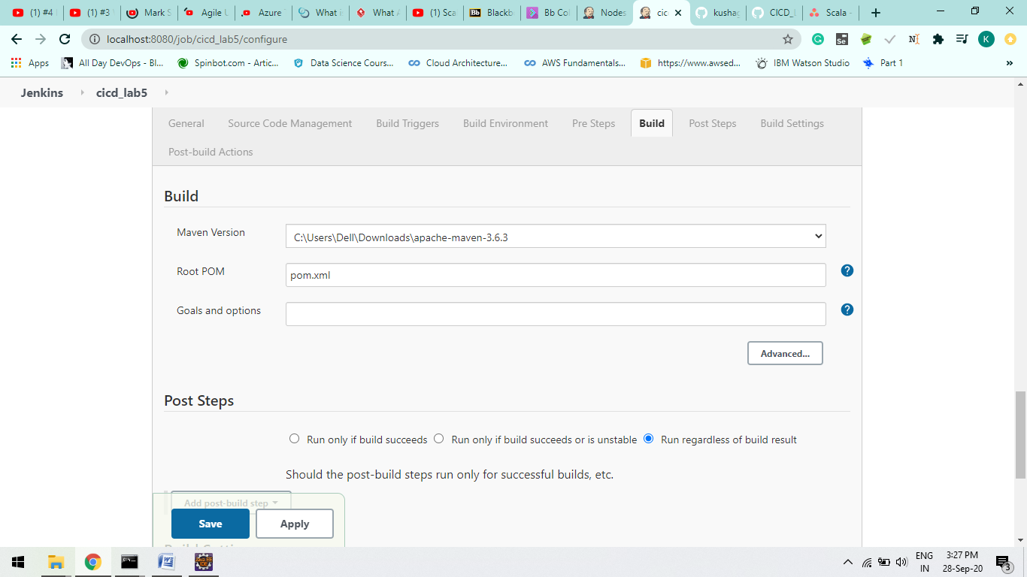

**Step-6:**

Now we have to link it with the Slave_1 we have create

Goto “general” Selects Restrict where the project can be run and type the Slave project name.

Save your all configurations and Build the project.

A.

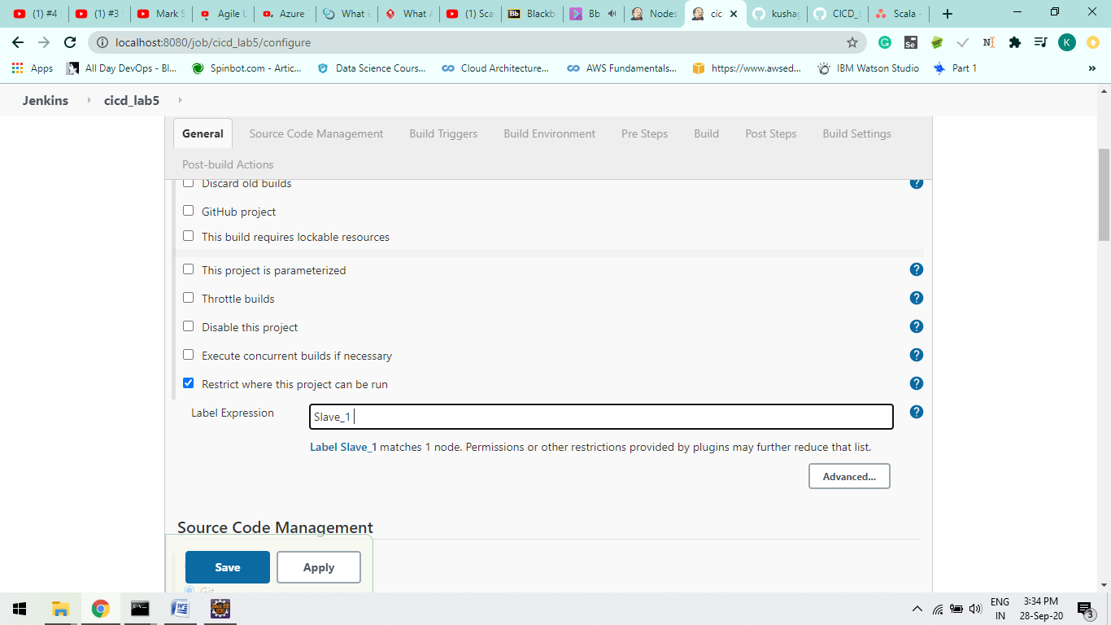

**Step-7:**

Click on Console output and check buid is successful or not.

If not check your configurations file and correct it.

Our project will save in our workspace directory in our local machine.

In our Earlier configuration we use Maven Clean Goal.

OutPut :

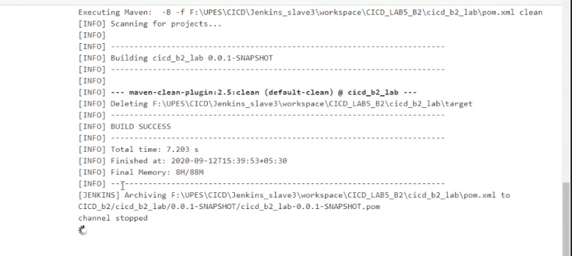

B.

Here your project get stored in Slave.

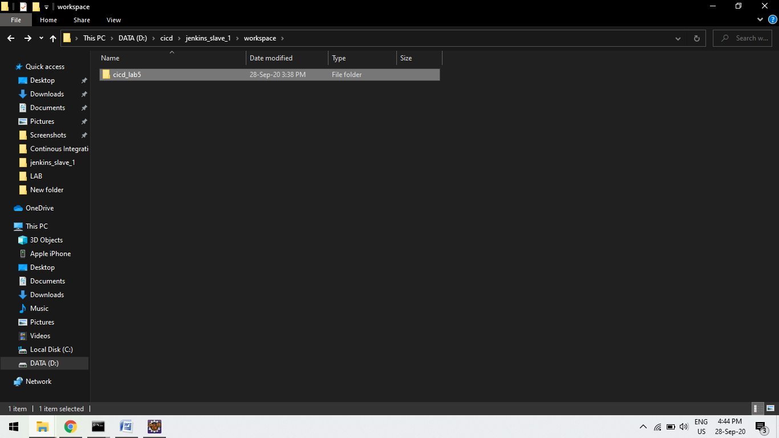

CICD LAB-7 Experiment (Ocean Blue Plugin)

BlueOcean Plugin Install:-

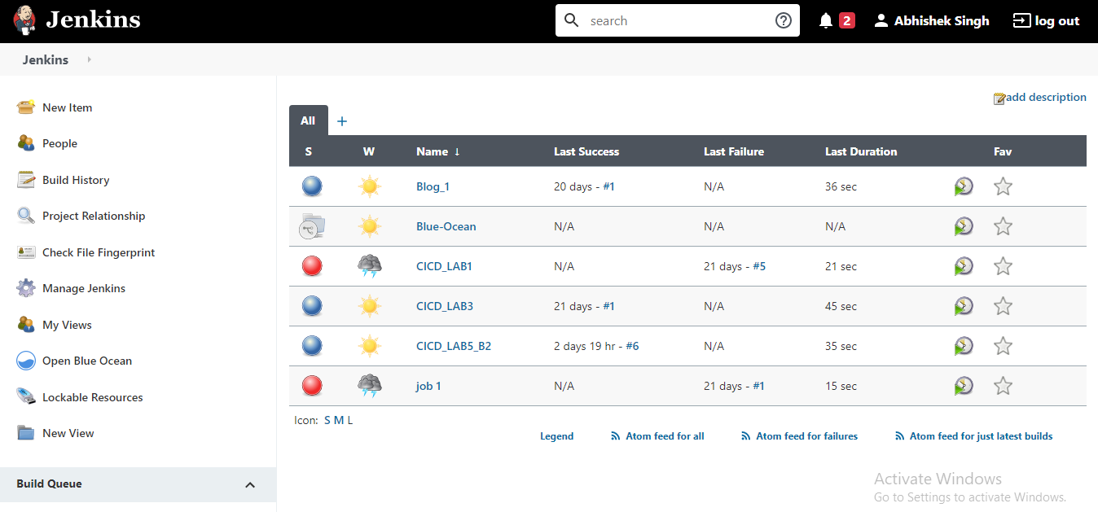

Jenkins File at GitHub:-

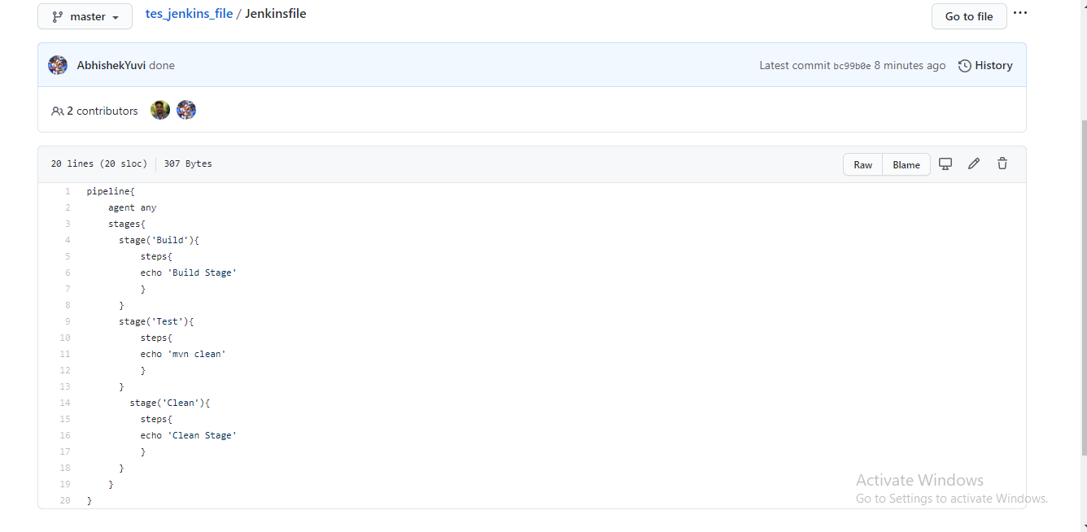

Pipeline Created:-

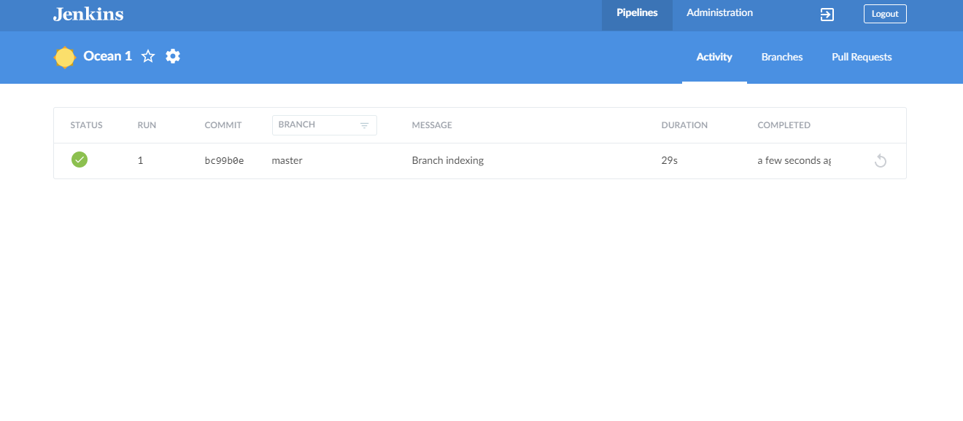

OUTPUT:-

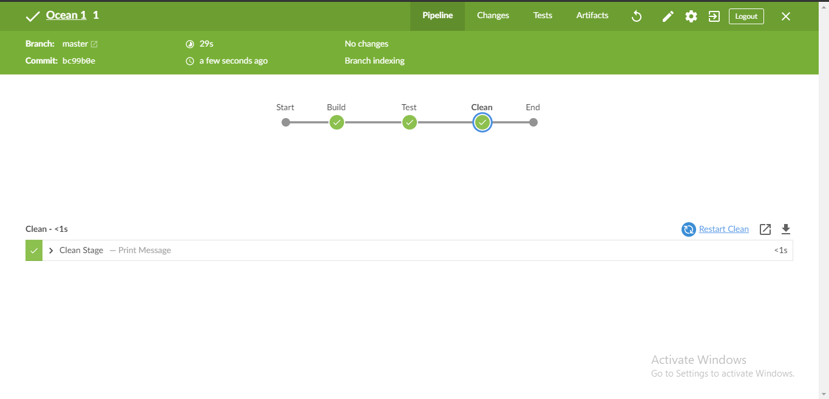

# Exp-8

AIM : Hosting the jar file to nexus so that become available to other developers

Deploying maven created jar file at nexus repository manager platform.

Step-1:

Download nexus 3.18.1-01. Extract it you will find two file :

1. nexus-3.18.1-01 b. sonatype-work (here Configurations are stored)

run command : nexus.exe /run

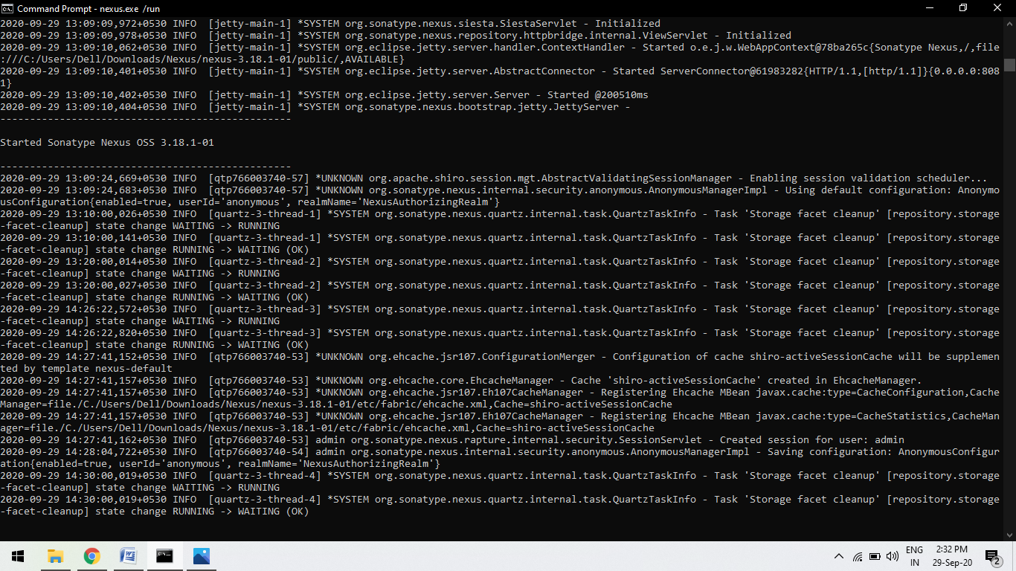

You will such screen in your command line.

Step-2

Open browser and type localhost:8081

Nexus Repository Dashboard will be open.

Sign-in in you dashboard, It will ask for the password first

Configure Your password:

Goto “sonatype-work > nexus3>admin.password”

Open the file admin.password, Copy the unique/one time key and paste at the password option

After this it will ask for the new password and submit and you will enter in your nexus Homepage.

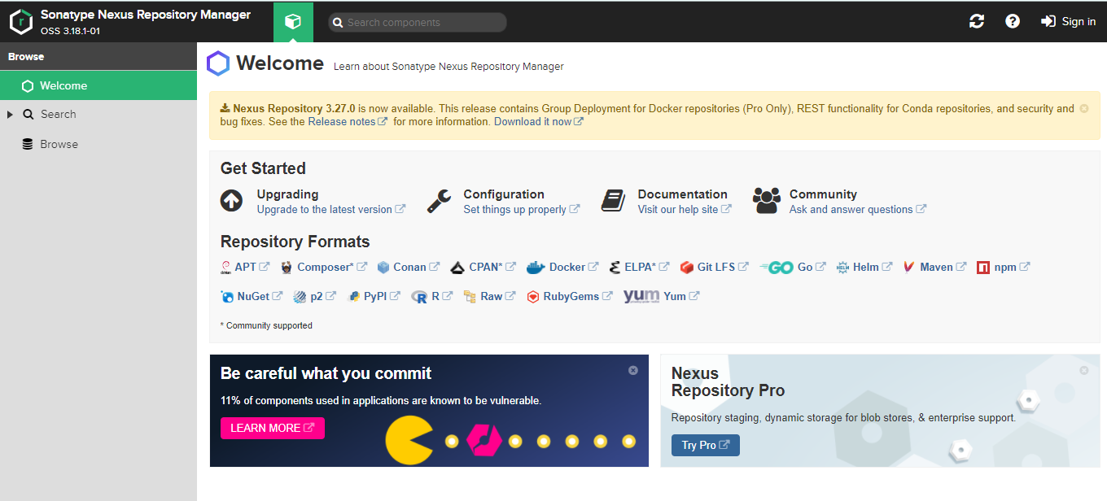

Step-3:

To Create Repository

Go to “Setting> Repository> Create Repository” and click

Now select “maven (hosted)” type repository because we are working on a maven project.

Configurations required :

1. Give name for the project
2. In Version policy: Select “Snapshot” as our maven project version in snapshot.
3. In Hosted : Select Allow redeploy so we can re-deploy it at anytime.

Now Create the repo.

Step-4:

Goto maven folder location , open Conf folder and then open settings xml document.

Write the below command too.

1. Id can be anything according to you.
2. Username and password same as nexus repo manager web application

<server><id>UPES</id><username>admin</username> <password>Kushagra@121</password> </server>

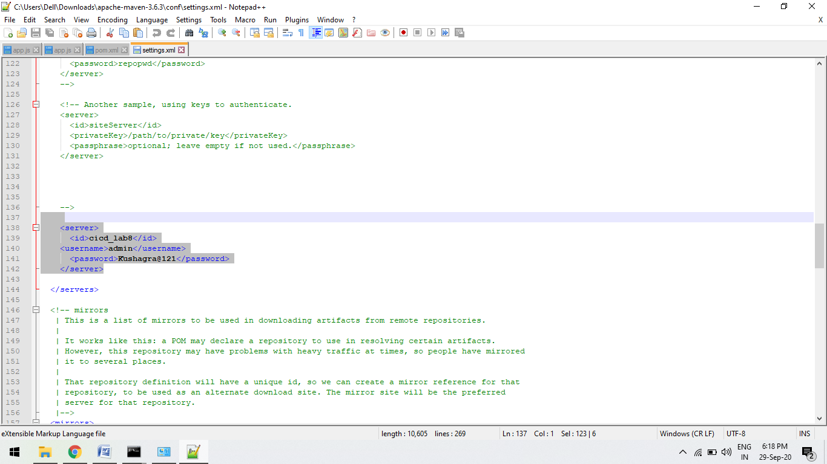

Step-5:

Since we have to deploy so we will run mvn deploy command.

For this we have to some changes in our maven project pom file to connect to the nexus repo manager.

Configurations:

<maven.compiler.source>1.6</maven.compiler.source>

<maven.compiler.target>1.6</maven.compiler.target>

<distributionManagement>

<snapshotRepository>

<id>upes</id>

<name>upes</name>

<url>http://localhost:8081/repository/cicd_lab8/</url>

</snapshotRepository>

</distributionManagement>

A.

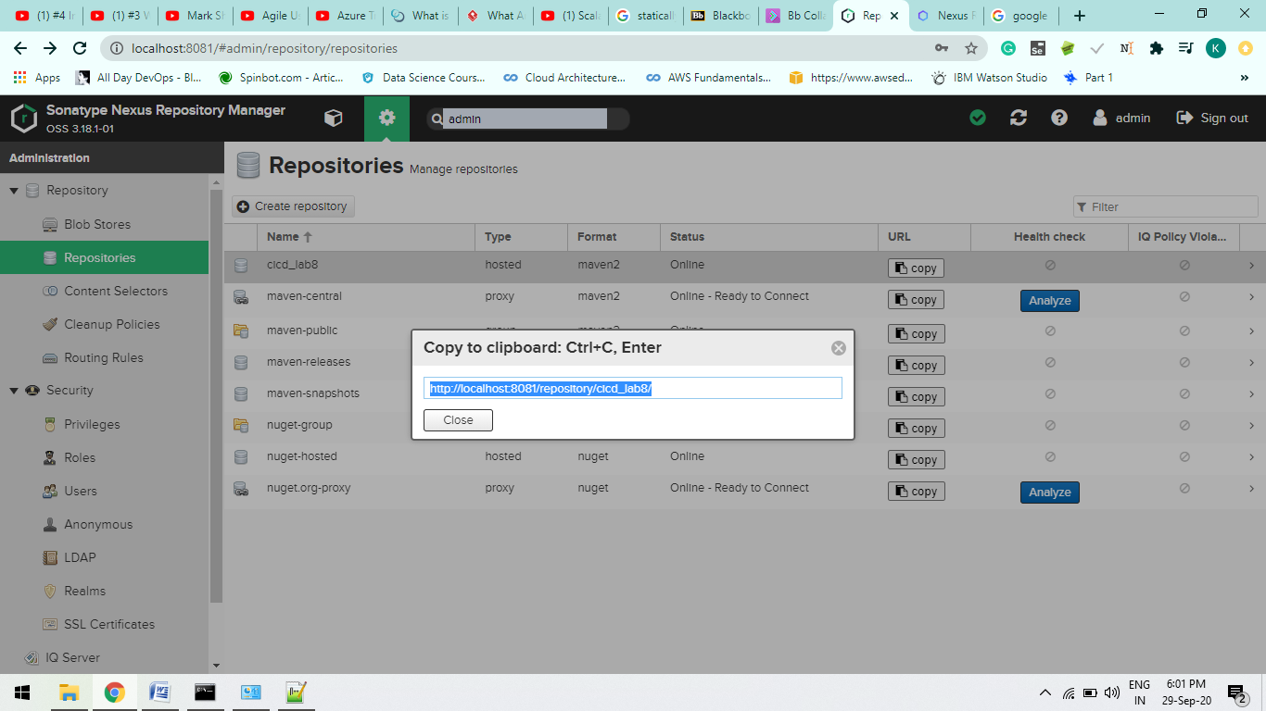

B.

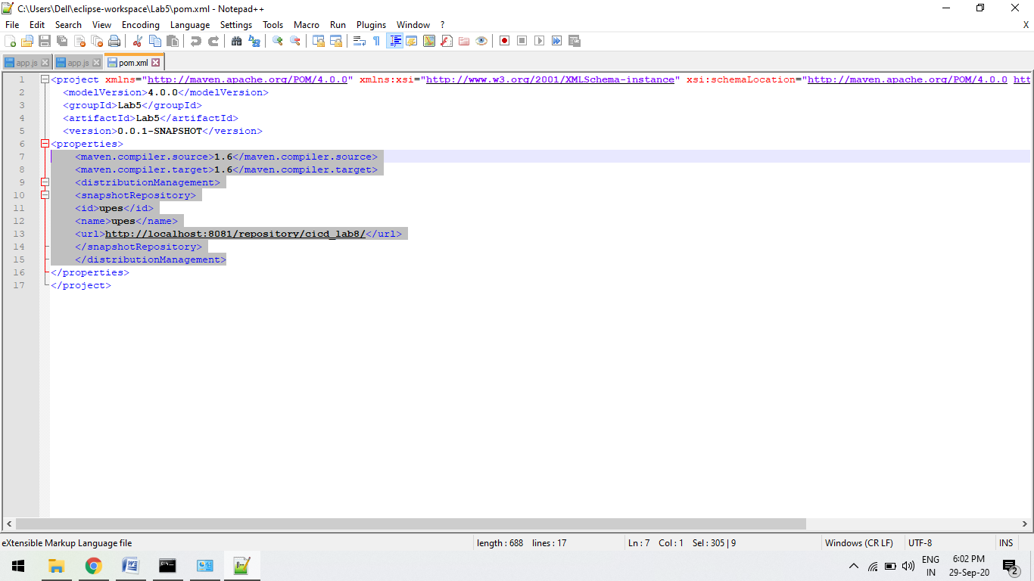

Step-6:

Goto the maven project where pom file is stored.

Run command “mvn deploy”

This command will automatically run the maven goal before the deploy goal like clean and install goal of maven.

jar file will be create and will host the jar file to the nexus repo manager.

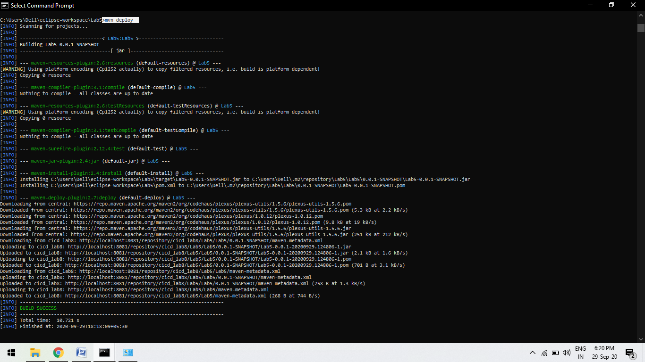

B.

